ELP Report for Website
School of Agriculture

1 | Mushroom Production Technology (ELP-PP-401)
2 | Production Technology for Bio-agents and Bio-fertilizers (ELP-ENT-402)
3 | Commercial Beekeeping (ENT-ELP-401)
4 | Commercial Horticulture (Vegetable and Spice Crop Production) (ELP-HORT-401)
5 | Floriculture and Landscaping (ELP-HORT-402)
6 | Processing of Fruits and Vegetables for Value Addition (ELP-HORT-403)
7 | Commercial Nursery Establishment and Mass Multiplication of Horticultural Crops (ELP-HORT-404)
8 | Protected Cultivation of High Value Horticulture Crops (ELP-HORT-405)
9 | Commercial Agriculture (Poultry Production Technology) (ELP-AHS-411)
10 | Soil, Water and Plant Testing (ELP-SS-401)
11 | Seed Production and Technology (ELP-GPB-401)
12 | Organic Production Technology (ELP-AGRON-402)

Commercial Beekeeping
(ELP-ENT-401)

- To provide practical knowledge of beekeeping and hive management
- To develop entrepreneurial skills in honey and bee product production
- To understand the role of bees in pollination and crop productivity
- To train students in scientific methods of honey extraction and processing
- To promote self-employment opportunities in apiculture
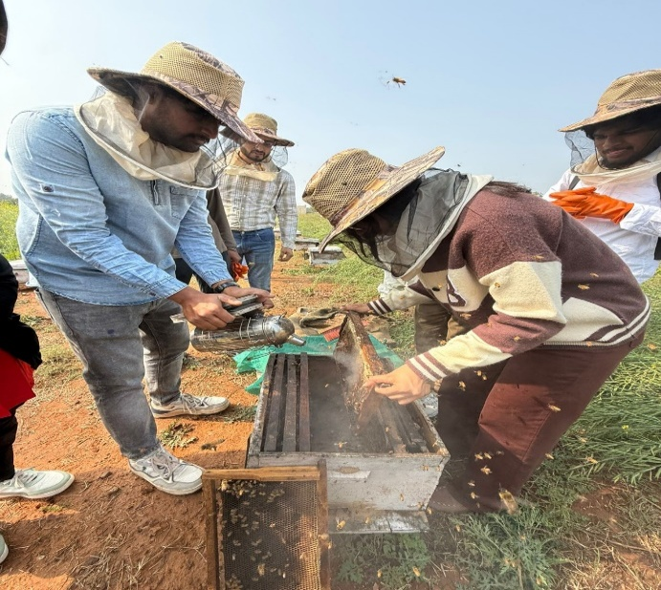
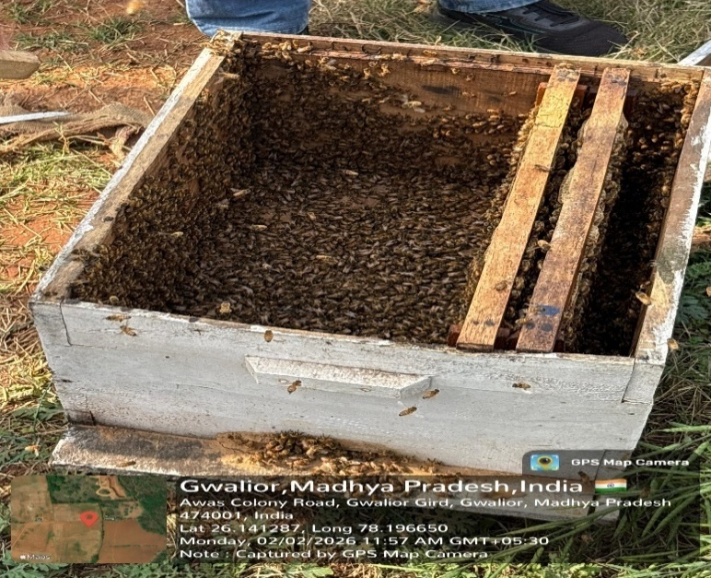
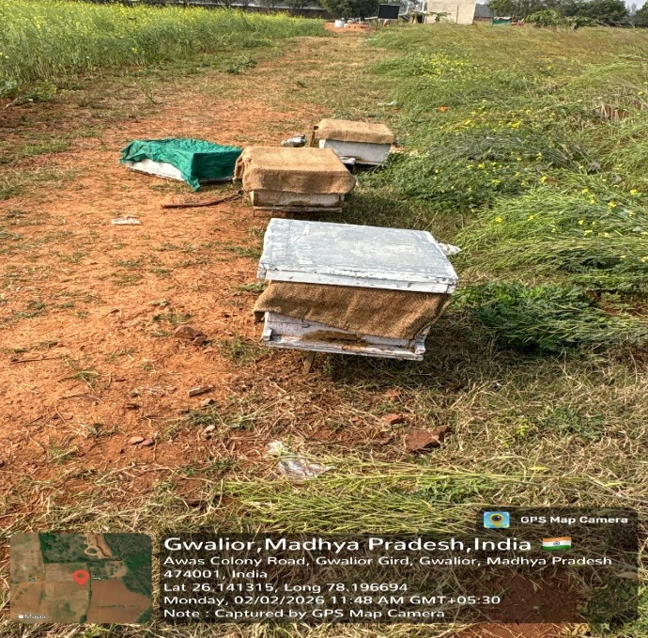
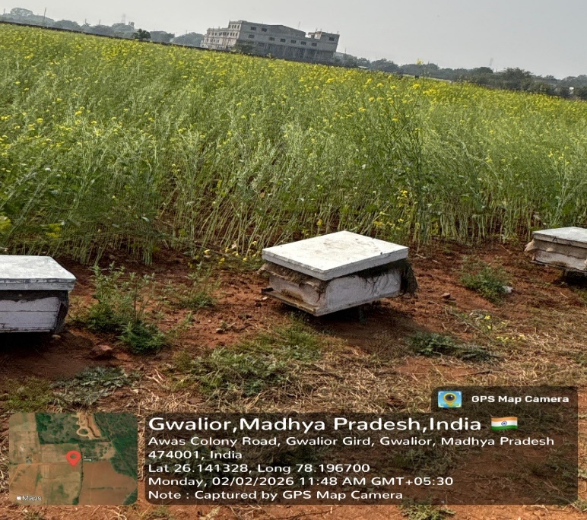
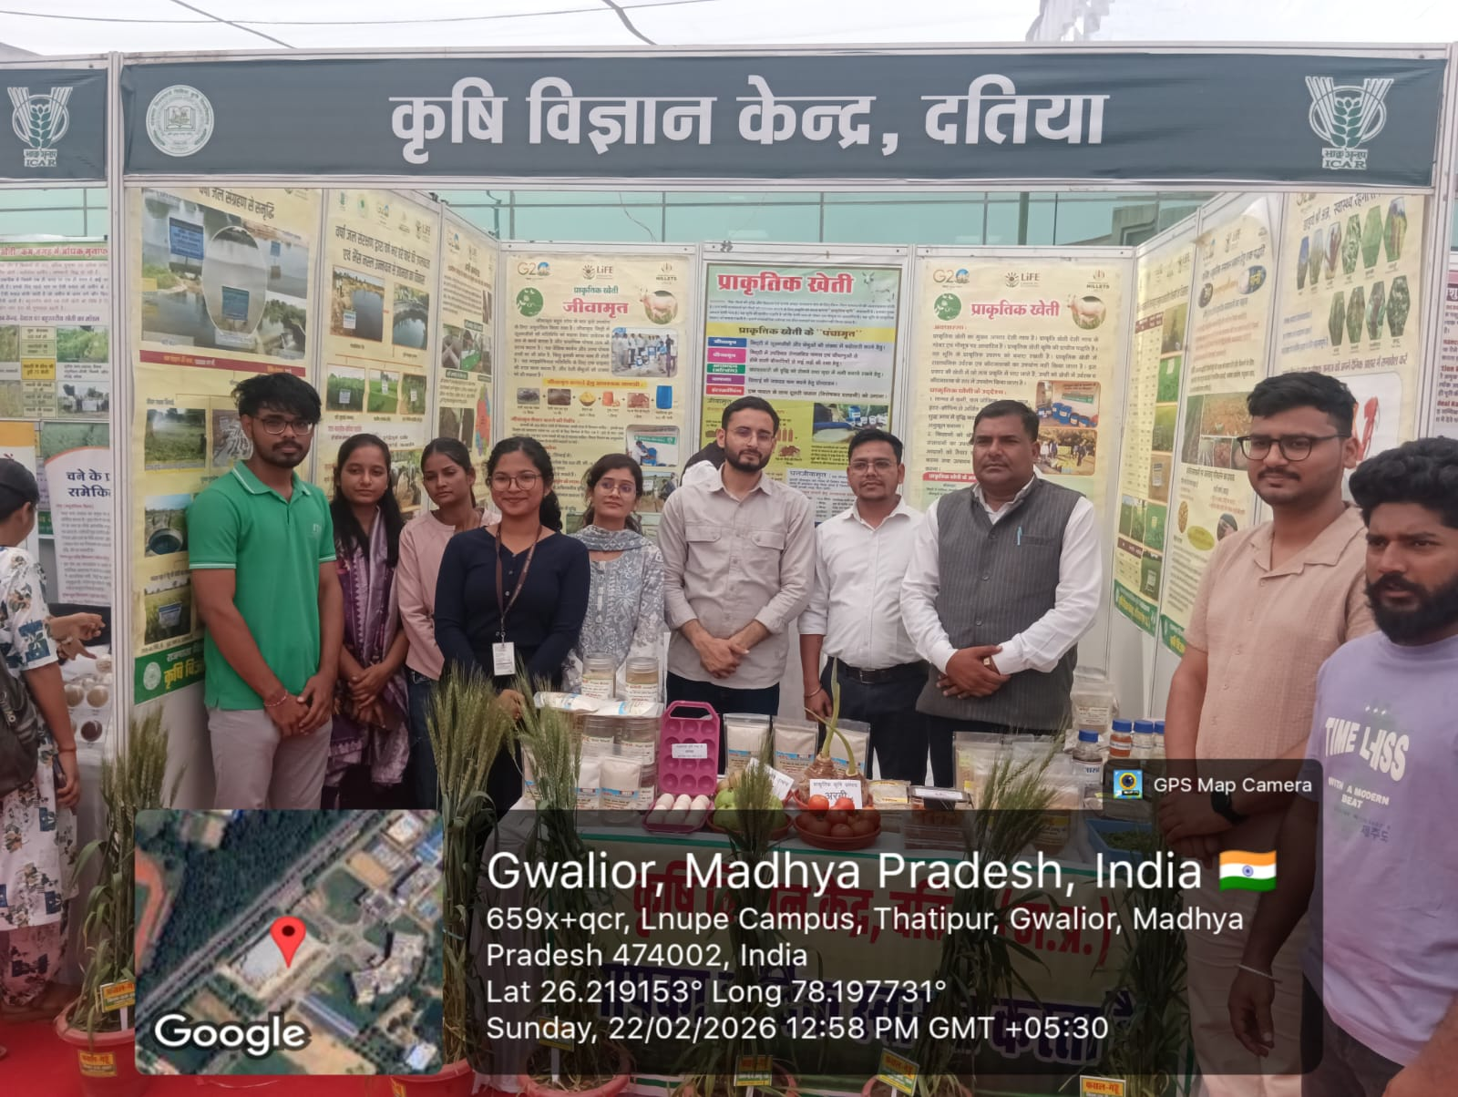
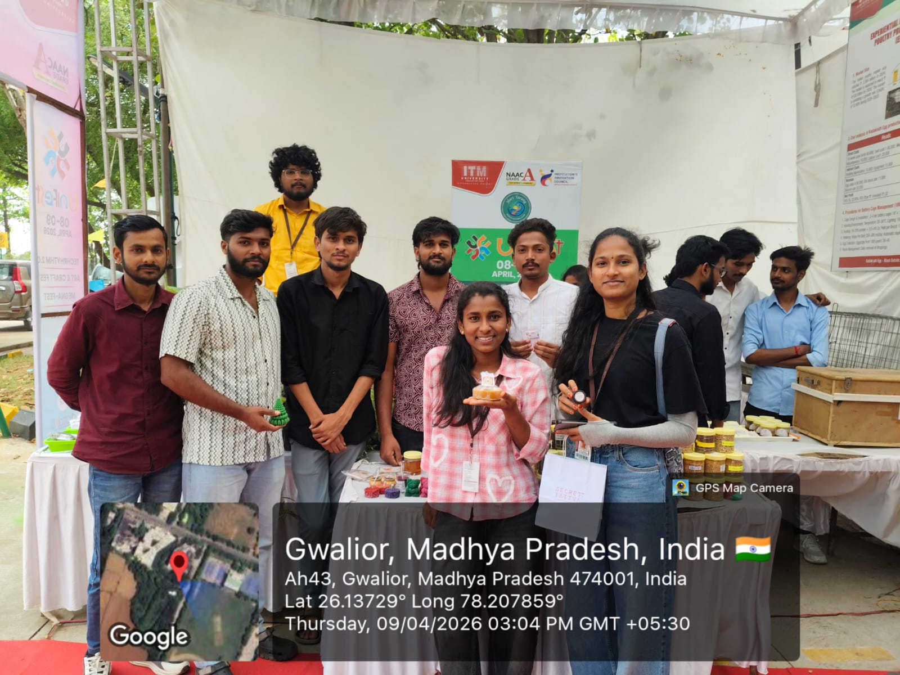
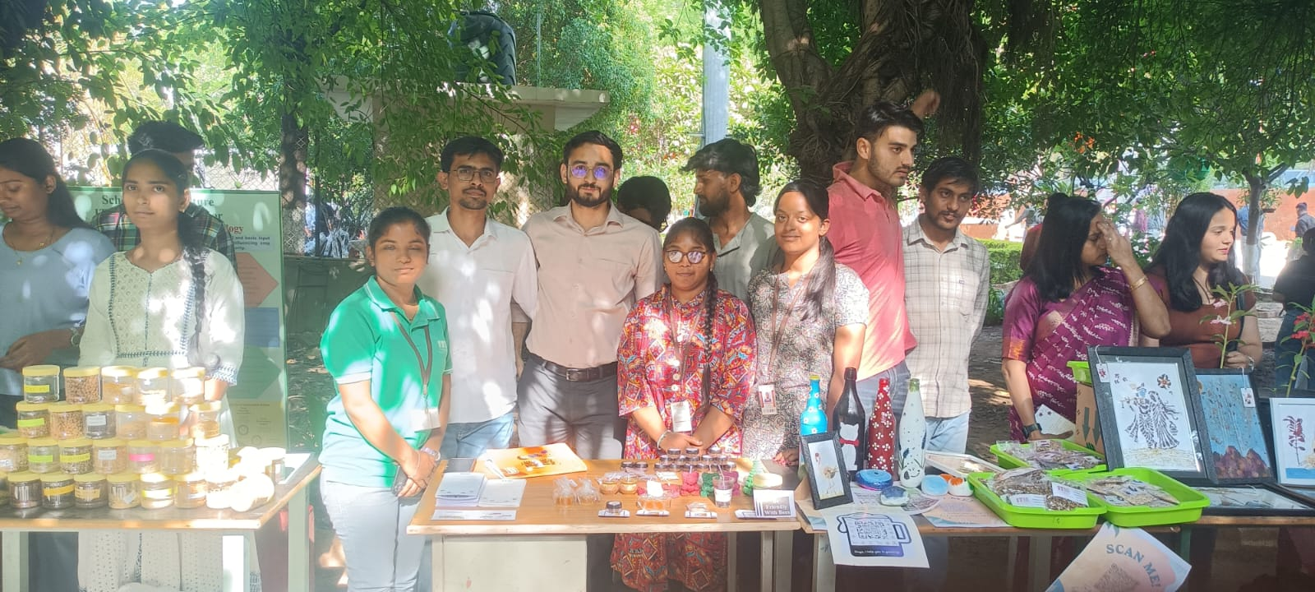

LIST OF STUDENTS PARTICIPATED
S. No. | Name Of Student | ENROLLMENT No. | Programme/Department
1 | M.Bhavana | BAGN1AG22115 | B.Sc. (Hons.) Ag.
2 | Kedar Singh Rawat | BAHN1AG22005 | B.Sc. (Hons.) Horti.
3 | V.Hari Krishna Reddy | BAGN1AG22126 | B.Sc. (Hons.) Ag.
4 | J.Likitha | BAGN1AG22106 | B.Sc. (Hons.) Ag.
5 | P.Hari | BAGN1AG22077 | B.Sc. (Hons.) Ag.
6 | M.Bhavana | BAGN1AG22115 | B.Sc. (Hons.) Ag.
7 | B.Anjali | BAGN1AG22193 | B.Sc. (Hons.) Ag.
8 | Bakki Manish | BAHN1AG22020 | B.Sc. (Hons.) Horti.
9 | Nikhil Sharma | BAHN1AG22008 | B.Sc. (Hons.) Horti.
 | Ritik Sharma | BAHN1AG22003 | B.Sc. (Hons.) Horti.
10 | Anuj Joshi | BAGN1AG22180 | B.Sc. (Hons.) Ag.
11 | Shreya | BAGN1AG22008 | B.Sc. (Hons.) Ag.
12 | N.Dinesh Reddy | BAGN1AG22131 | B.Sc. (Hons.) Ag.
13 | N.V.Pujitha | BAGN1AG22181 | B.Sc. (Hons.) Ag.
14 | Edururi Jagan Mohan Reddy | BAHN1AG22018 | B.Sc. (Hons.) Horti.
15 | Ch Prasanth | BAGN1AG22227 | B.Sc. (Hons.) Ag.
16 | Khushi Singh | BAGN1AG22248 | B.Sc. (Hons.) Ag.
17 | Cherukuri Karthik | BAGN1AG22107 | B.Sc. (Hons.) Ag.
18 | Abhishek.T.S | BAGN1AG22011 | B.Sc. (Hons.) Ag.
19 | Gunupuru Sharmila Naidu | BAGN1AG22098 | B.Sc. (Hons.) Ag.
20 | Uttaradi Rana Pratap | BAGN1AG22169 | B.Sc. (Hons.) Ag.
21 | N.Dinesh Reddy | BAGN1AG22131 | B.Sc. (Hons.) Ag.
22 | Uttaradi Rana Pratap | BAGN1AG22169 | B.Sc. (Hons.) Ag.
23 | Bujbale Shivaprasad | BAGN1AG22139 | B.Sc. (Hons.) Ag.
24 | N.V.Pujitha | BAGN1AG22181 | B.Sc. (Hons.) Ag.
25 | Sangala Shiva Kumar | BAGN1AG22109 | B.Sc. (Hons.) Ag.
26 | M Vaishanvi | BAGN1AG22138 | B.Sc. (Hons.) Ag.
27 | M Lokesh | BAG1NAG22284 | B.Sc. (Hons.) Ag.
28 | J.Likitha | BAGN1AG22106 | B.Sc. (Hons.) Ag.
29 | Atturla Sanjukta Rao | BAGN1AG22070 | B.Sc. (Hons.) Ag.
30 | Puchaginjala Theja | BAGN1AG22124 | B.Sc. (Hons.) Ag.
31 | M.Guru Viswanadh Yadav | BAGN1AG22223 | B.Sc. (Hons.) Ag.
32 | C.Gunashree | BAGN1AG22129 | B.Sc. (Hons.) Ag.
33 | P.Nandini | BAGN1AG22046 | B.Sc. (Hons.) Ag.
34 | Gopikrishna | BAGN1AG22110 | B.Sc. (Hons.) Ag.
35 | Guna Yaswant | BAGN1AG22081 | B.Sc. (Hons.) Ag.
36 | Abhishek singh | BAGN1AG22225 | B.Sc. (Hons.) Ag.

Production technology of Bioagents and Biofertilizers
ELP-ENT-402
- To learn the techniques for isolation of beneficial microorganisms used in biofertilizers and biopesticides from soil and plant samples.
- To understand the methods of pure culture maintenance and cultivation of selected microbial strains under laboratory conditions.
- To develop skills in mass production and formulation of biofertilizers and biopesticides using suitable media and fermentation techniques.
- To gain knowledge of packaging, labeling, and storage practices to maintain quality, viability, and shelf life of the products.
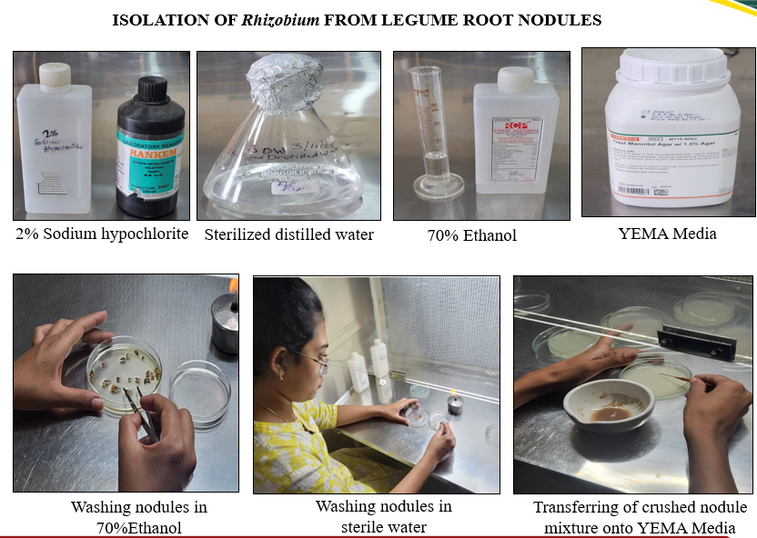
Figure 1. Isolation of Rhizobium nodules from legume crop

PHOTOGRAPHS OF ELP EXPO 4.0

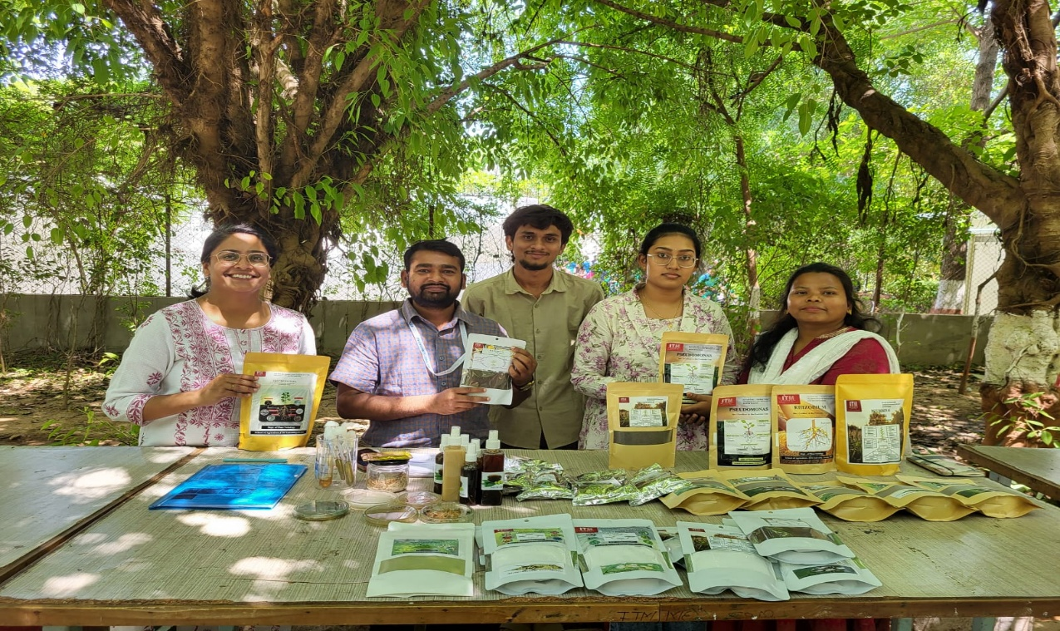

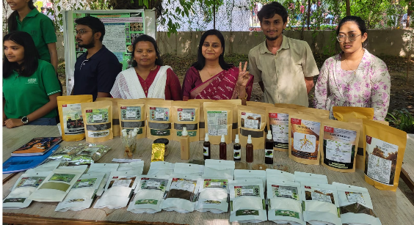

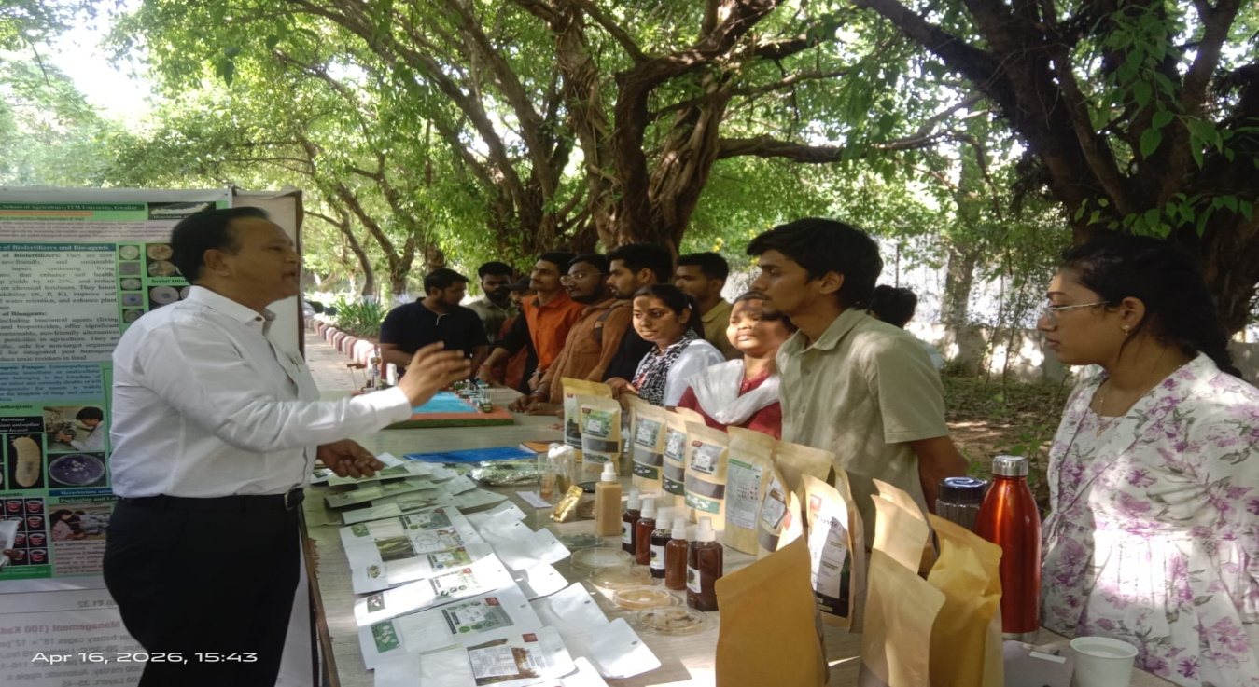
LIST OF STUDENTS PARTICIPATED
S. No. | Name of Student | Enrollment No. | Programme/Department
1 | V. Hari Krishna Reddy | BAGN1AG22126 | BSc(Hons).Agriculture
2 | Vuddanti Sravani | BAGN1AG22207 | BSc(Hons).Agriculture

Mushroom Cultivation Technology
ELP-PP-401

- To provide hands-on training on cultivation technology of different types of edible mushrooms and spawns production.
- To build confidence and to work in project mode.
- To acquire mushroom enterprise management capabilities.
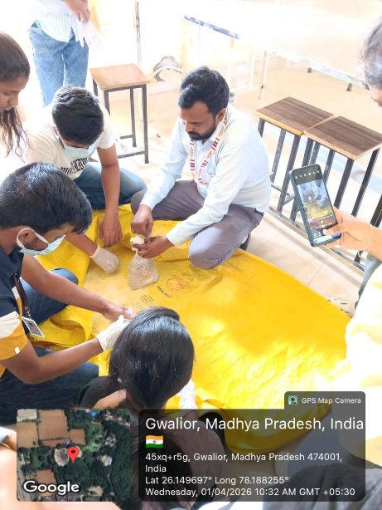
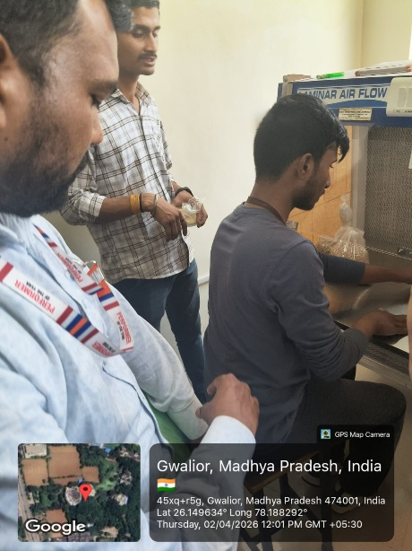
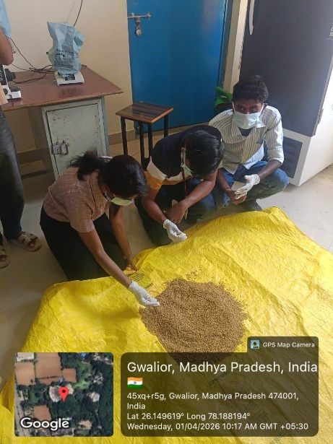
Oyster mushroom substrate preparation
Preparation of the button mushroom compost

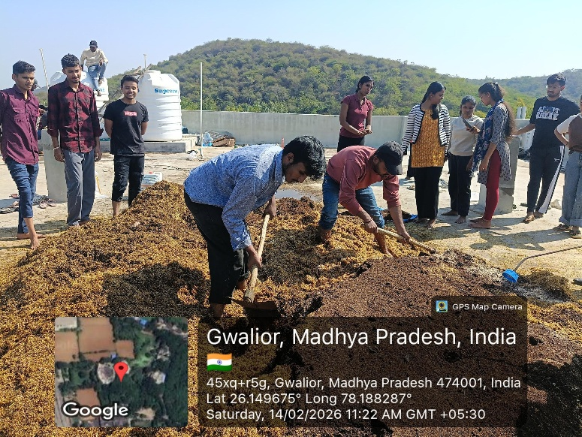
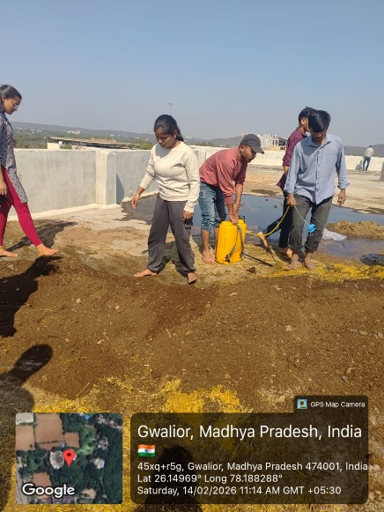
Cleaning of the mushroom lab
Bagging for oyster mushroom
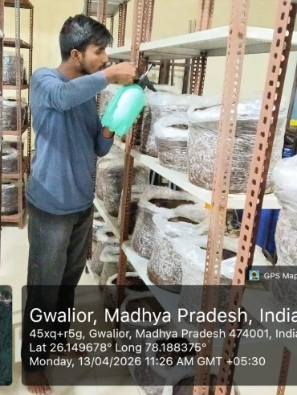
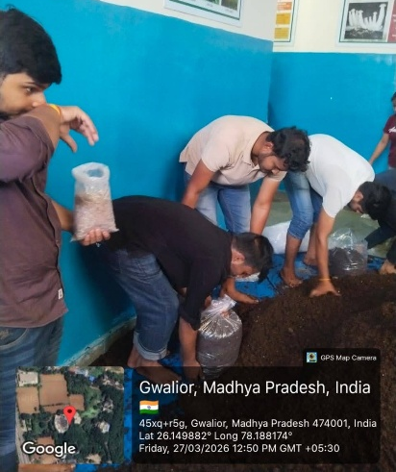
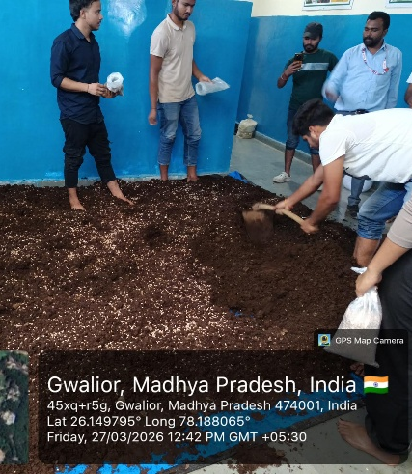
Preparation of the mushroom spawn
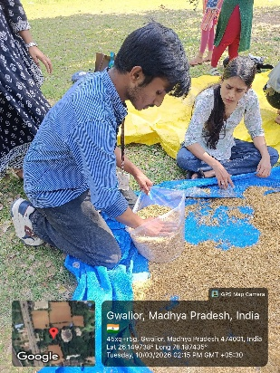
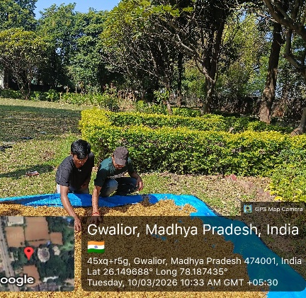
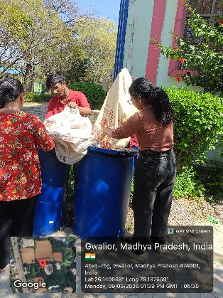
Spraying water
Spawning and bagging for button mushroom
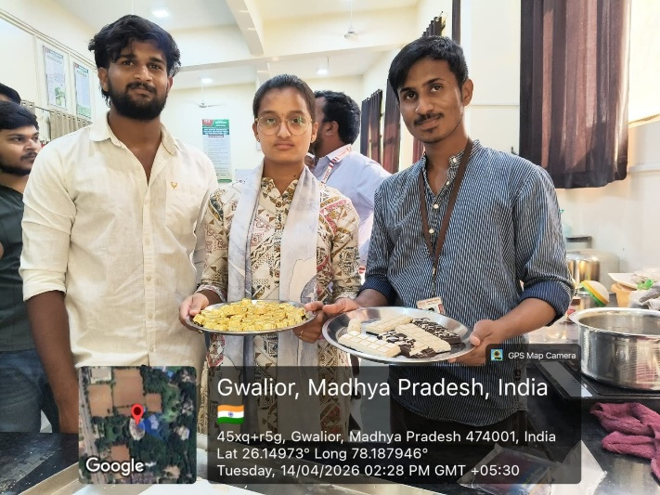
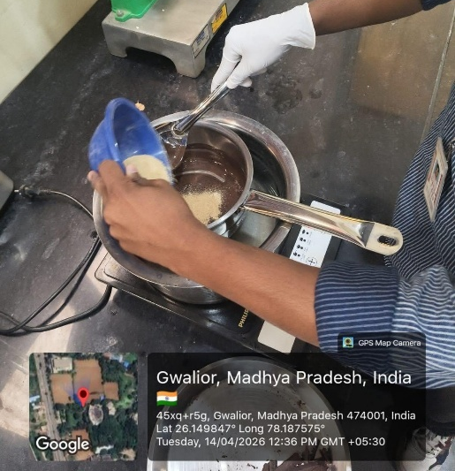
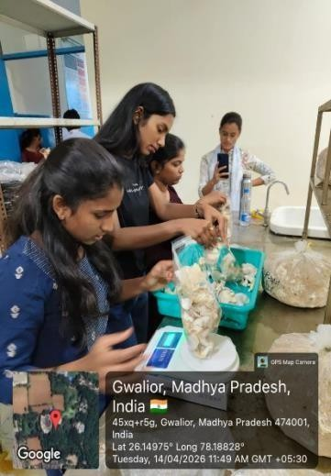
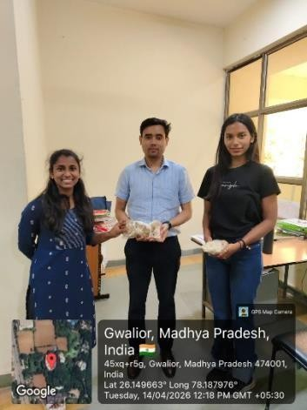
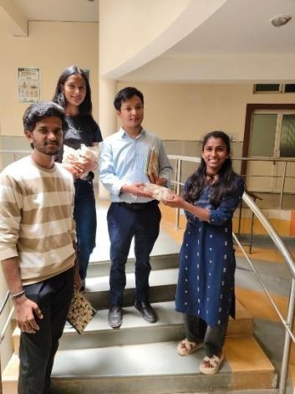
Harvesting and sale of oyster mushroom
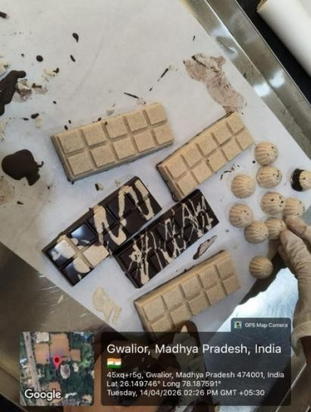
Mushroom chocolate preparation
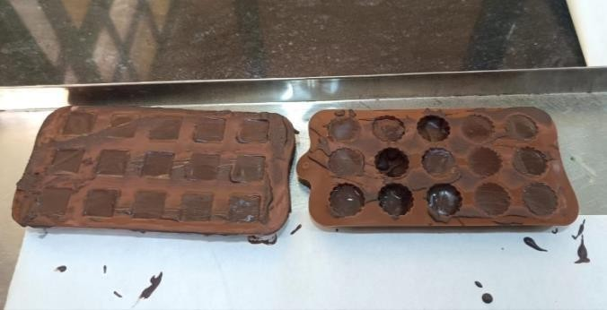
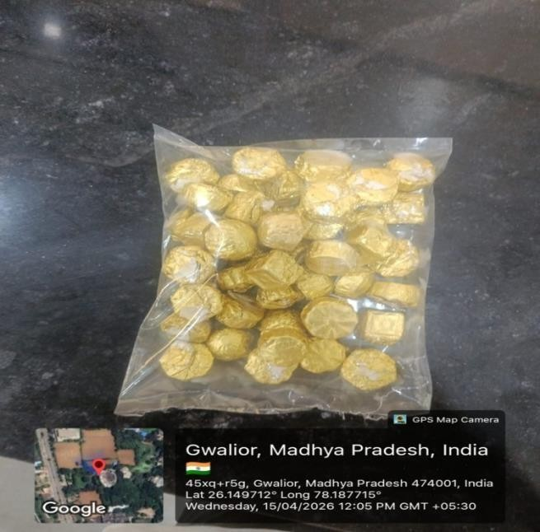

Mushroom chocolate preparation

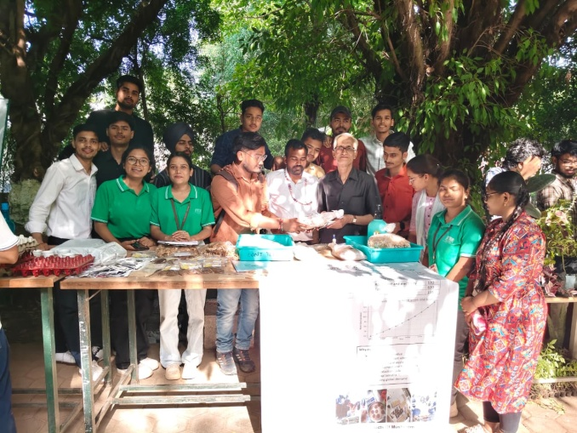
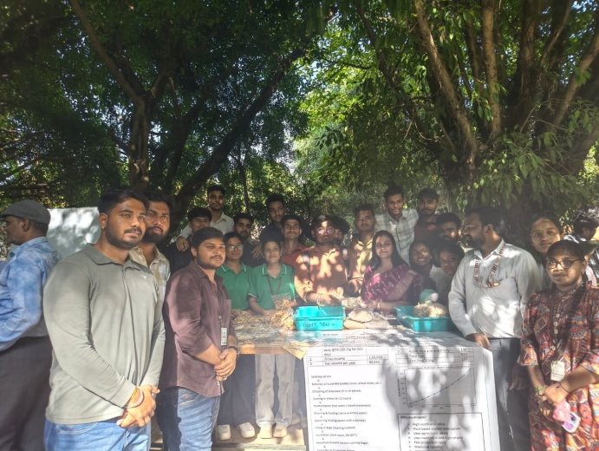
Photographs of ELP Expo 4.0
Mushroom cookies preparation
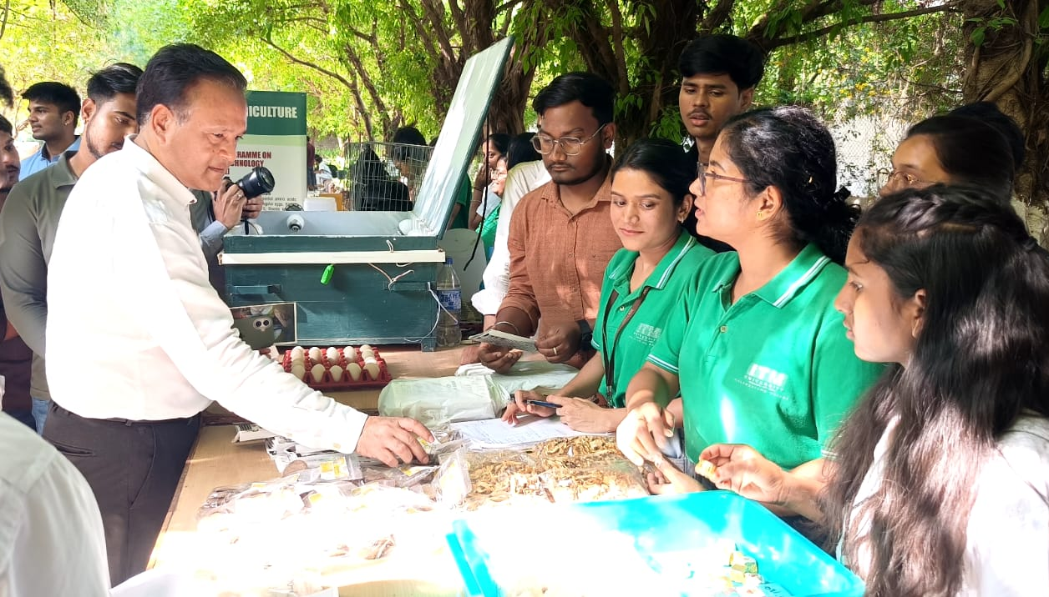

7. List of Students Participated
S.No | Roll Number | Name of the Student | Programme
1 | BAGN1AG22002 | Manavendr Upadhya | B.Sc. (Hons) Agriculture
2 | BAGN1AG22003 | Ayush Mandal | B.Sc. (Hons) Agriculture
3 | BAGN1AG22006 | Animeha Parmar | B.Sc. (Hons) Agriculture
4 | BAGN1AG22011 | Abhishek TS | B.Sc. (Hons) Agriculture
5 | BAGN1AG22013 | Ankit | B.Sc. (Hons) Agriculture
6 | BAGN1AG22014 | Sourav Rajput | B.Sc. (Hons) Agriculture
7 | BAGN1AG22020 | Aditya Kumar | B.Sc. (Hons) Agriculture
8 | BAGN1AG22022 | Vishesh Tyagi | B.Sc. (Hons) Agriculture
9 | BAGN1AG22025 | Shubam Singh | B.Sc. (Hons) Agriculture
10 | BAGN1AG22027 | Subhajit Nath | B.Sc. (Hons) Agriculture
11 | BAGN1AG22028 | Tanishq Raj Singh | B.Sc. (Hons) Agriculture
12 | BAGN1AG22033 | Udit Rajput | B.Sc. (Hons) Agriculture
13 | BAGN1AG22036 | Anuroodh Shivhare | B.Sc. (Hons) Agriculture
14 | BAGN1AG22046 | Nandini Patel | B.Sc. (Hons) Agriculture
15 | BAGN1AG22050 | Saurabh Kumar | B.Sc. (Hons) Agriculture
16 | BAGN1AG22051 | Rishi Goutam | B.Sc. (Hons) Agriculture
17 | BAGN1AG22054 | Anushmita Shrivastav | B.Sc. (Hons) Agriculture
18 | BAGN1AG22056 | Shiva Yadav | B.Sc. (Hons) Agriculture
19 | BAGN1AG22057 | Khushi Sahu | B.Sc. (Hons) Agriculture
20 | BAGN1AG22061 | Nishit Sharma | B.Sc. (Hons) Agriculture
21 | BAGN1AG22065 | Subhangi | B.Sc. (Hons) Agriculture
22 | BAGN1AG22068 | Chayan Mahanthy | B.Sc. (Hons) Agriculture
23 | BAGN1AG22069 | Aakarsh | B.Sc. (Hons) Agriculture
24 | BAGN1AG22070 | A. Sanjukta Rao | B.Sc. (Hons) Agriculture
25 | BAGN1AG22077 | Hari Choudary | B.Sc. (Hons) Agriculture
26 | BAGN1AG22082 | Shubhanshu Chaubey | B.Sc. (Hons) Agriculture
27 | BAGN1AG22085 | Pijush Mandal | B.Sc. (Hons) Agriculture
28 | BAGN1AG22106 | J Likitha | B.Sc. (Hons) Agriculture
29 | BAGN1AG22107 | C Karthik | B.Sc. (Hons) Agriculture
30 | BAGN1AG22115 | M Bhavana | B.Sc. (Hons) Agriculture
31 | BAGN1AG22120 | Rishabh Khushwaha | B.Sc. (Hons) Agriculture
32 | BAGN1AG22124 | P Theja | B.Sc. (Hons) Agriculture
33 | BAGN1AG22129 | C Gunashree | B.Sc. (Hons) Agriculture
34 | BAGN1AG22131 | Dinesh Reddy | B.Sc. (Hons) Agriculture
35 | BAGN1AG22139 | Shiva Prasad | B.Sc. (Hons) Agriculture
36 | BAGN1AG22147 | Aditya Kumar Mishra | B.Sc. (Hons) Agriculture
37 | BAGN1AG22148 | Himanshu Kumar | B.Sc. (Hons) Agriculture
38 | BAGN1AG22159 | Abhimanyu Kumar | B.Sc. (Hons) Agriculture
39 | BAGN1AG22169 | Rana Pratap | B.Sc. (Hons) Agriculture
40 | BAGN1AG22174 | Rahul Kumar | B.Sc. (Hons) Agriculture
41 | BAGN1AG22181 | Poojitha | B.Sc. (Hons) Agriculture
42 | BAGN1AG22189 | K Akhil | B.Sc. (Hons) Agriculture
43 | BAGN1AG22196 | Shaik Mustaqeem | B.Sc. (Hons) Agriculture
44 | BAGN1AG22201 | Prithu Sharma | B.Sc. (Hons) Agriculture
45 | BAGN1AG22204 | Prashanth | B.Sc. (Hons) Agriculture
46 | BAGN1AG22211 | Sakshi Priya | B.Sc. (Hons) Agriculture
47 | BAGN1AG22221 | Rudra Rajawat | B.Sc. (Hons) Agriculture
48 | BAGN1AG22227 | Ch Prashanth | B.Sc. (Hons) Agriculture
49 | BAGN1AG22234 | Jagadeeshwar | B.Sc. (Hons) Agriculture
50 | BAGN1AG22250 | Sadhana Kaur | B.Sc. (Hons) Agriculture
51 | BAGN1AG22271 | Ishwara Chand | B.Sc. (Hons) Agriculture
52 | BAGN1AG22279 | Jaskerat Singh | B.Sc. (Hons) Agriculture
53 | BAGN1AG22300 | Yathishri | B.Sc. (Hons) Agriculture

Soil, Plant and Water Testing

ELP-SS-401

  - To provide hands-on training in soil, water and plant analysis.
  - To assess soil fertility and recommend appropriate nutrient management practices.
  - To evaluate irrigation water quality for agricultural use.
  - To diagnose plant nutrient deficiencies through tissue analysis.
  - To introduce students to remote sensing technologies in agriculture.
  - To develop skills in data collection, analysis, and interpretation.
  - To promote precision farming and sustainable resource management.
  - To enhance problem-solving and decision-making abilities of students.

Pictorial presentation on Soil, Plant and Water Analysis

- Collection of Soil Sample
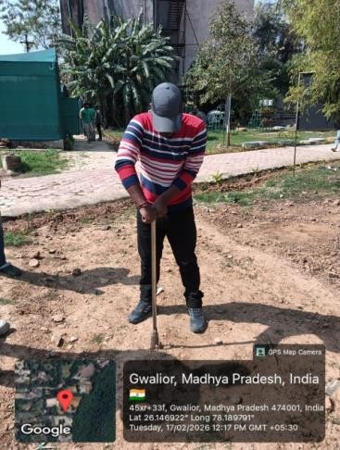
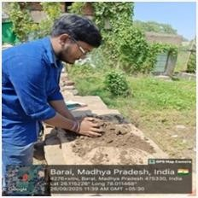
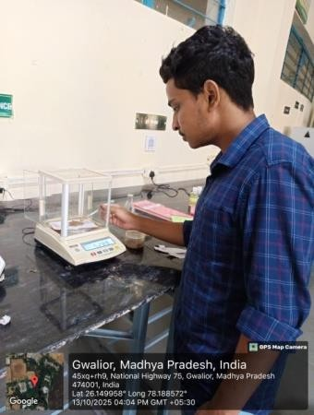

Analysis of Organic Carbon, available phosphorus & potassium
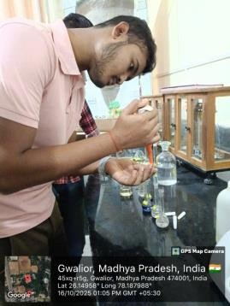
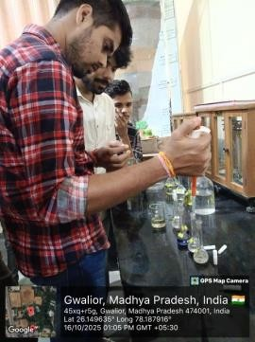
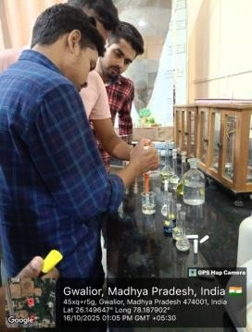
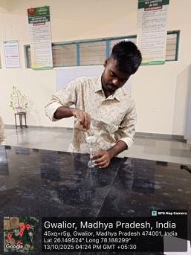
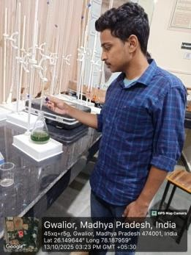

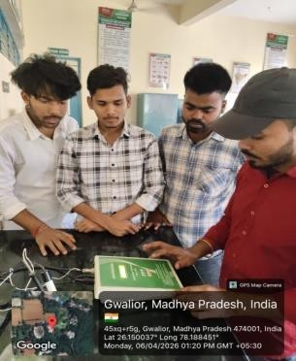
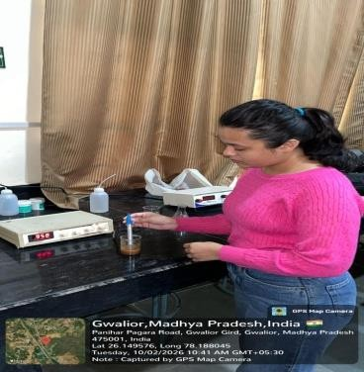
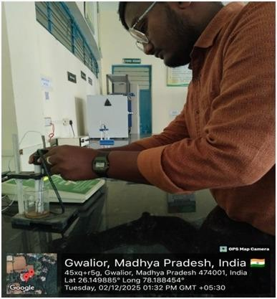
Analysis of Irrigation water pH, EC & TDS

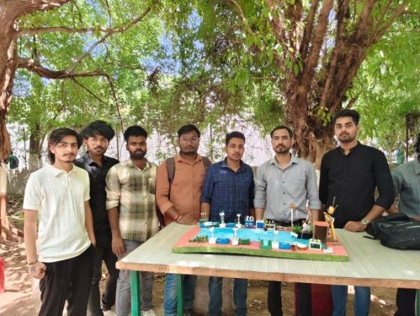
ELP EXPO 4.0

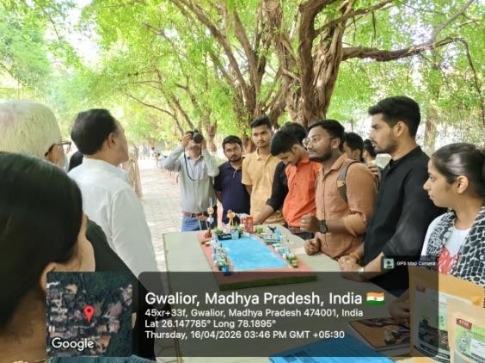

List of students participated in ELP EXPO 4.0

S.No. | Roll No. | Name | Programme
1. | BAGN1AG22085 | PIJUSH MANDAL | B.Sc.(hons) Agriculture
2. | BAGN1AG22068 | CHAYAN MAHANTY | B.Sc.(hons) Agriculture
3. | BAGN1AG22027 | SUBHAJIT NATH | B.Sc.(hons) Agriculture
4. | BAGN1AG22003 | AYUSH MONDAL | B.Sc.(hons) Agriculture
5. | BAGN1AG22020 | ADITYA KUMAR | B.Sc.(hons) Agriculture
6. | BAGN1AG22025 | SHUBHAM SINGH | B.Sc.(hons) Agriculture
7. | BAGN1AG22148 | HIMANSHU KUMAR | B.Sc.(hons) Agriculture
8. | BAGN1AG22174 | RAHUL KUMAR | B.Sc.(hons) Agriculture
9. | BAGN1AG22021 | KHUSHI NAYAK | B.Sc.(hons) Agriculture
10. | BAGN1AG22092 | KUNAL DHAKAR | B.Sc.(hons) Agriculture
11. | BAGN1AG22022 | VISHESH TYAGI | B.Sc.(hons) Agriculture
12. | BAGN1AG22030 | RIMJHIM BHARTI | B.Sc.(hons) Agriculture
13. | BAGN1AG22050 | SAURABH KUMAR | B.Sc.(hons) Agriculture

Soil health card
Soil Samples Collected From host Farmer Field. Farmers name – Manu lal
Address -Panihar village, tehsil – Ghatigaon , district – Gwalior , M.P.
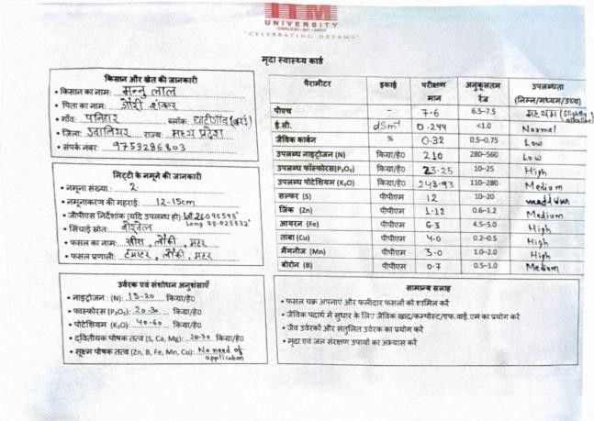

Seed Production Technology
ELP-GPB-401

- To understand principles of seed production, genetic purity, and certification standards
- To apply skills in soil analysis, crop planning, and field layout preparation
- To implement seed production practices such as isolation, rouging, weeding, and intercultural operations
- To analyze crop growth, pest and disease incidence, and field conditions
- To evaluate crop performance through field inspection, data observation, and quality assessment
- To develop skills in harvesting, threshing, and post-harvest management
- To perform seed sampling and laboratory quality testing (purity, germination, vigour, moisture)
- To adopt sustainable practices and biological inputs in seed production
- To strengthen analytical and decision-making abilities
- To design and manage a complete seed production system with economic evaluation

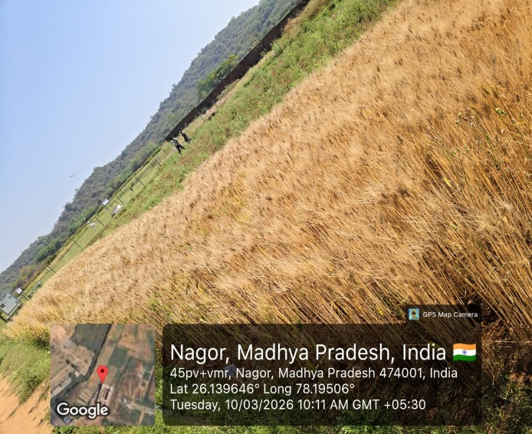Wheat Crop (Seed Production) field overview at Maturity Stage | 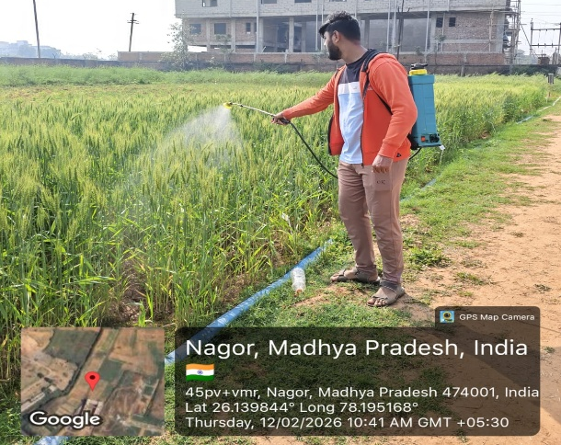Student applying bio-herbicide in wheat seed production field.
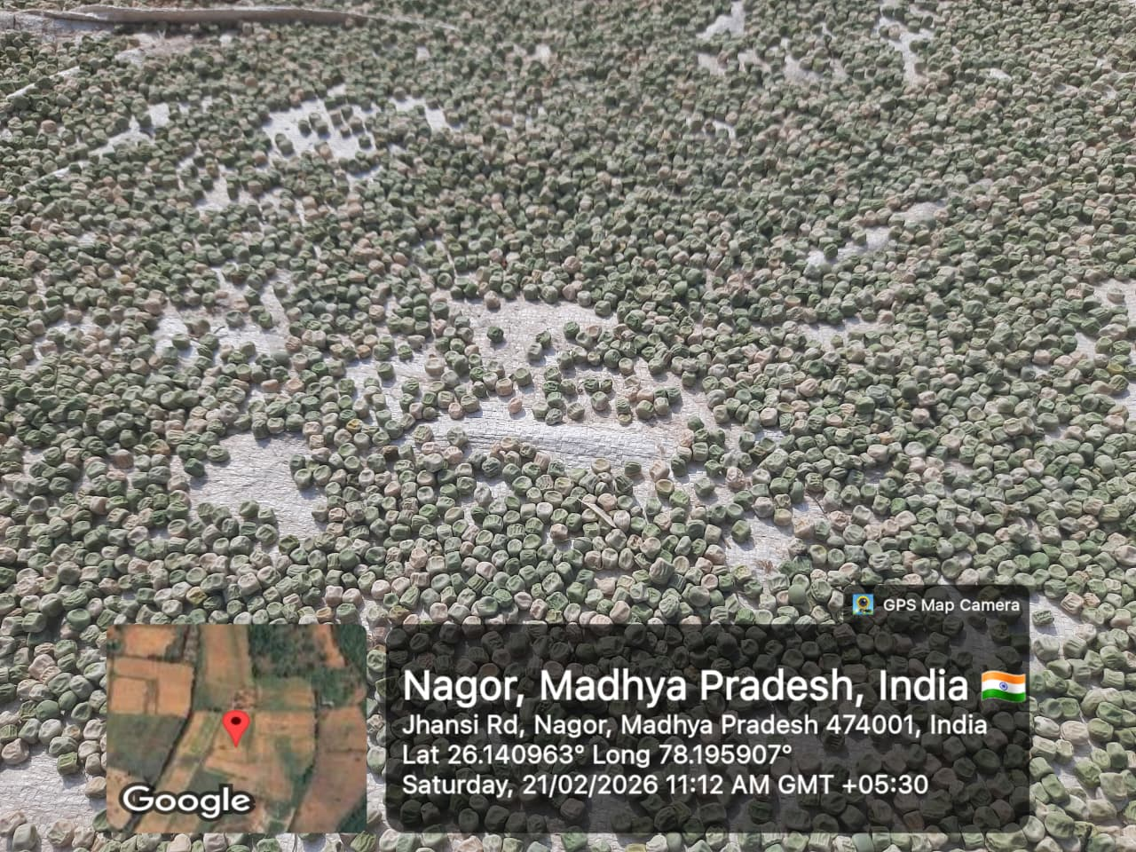Field pea seeds were processed and spread for sun drying to reduce moisture content. | 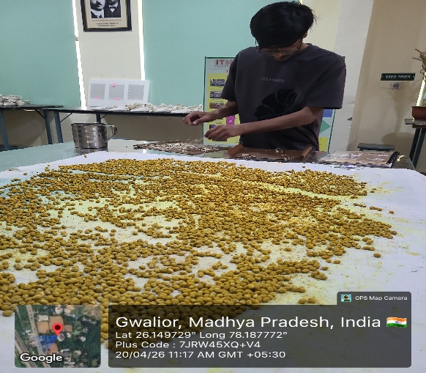Seed pelleting technique in soybean seeds with organic turmeric powder and neem leaf powder
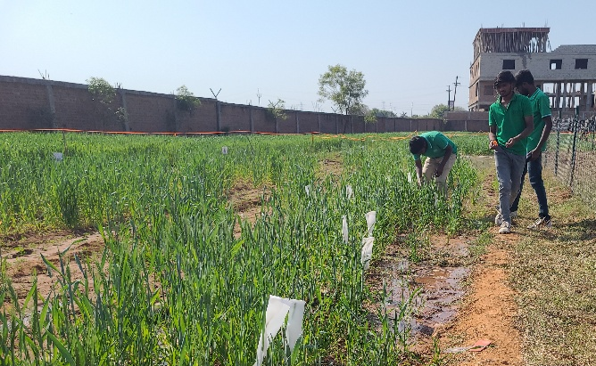Students are performing hybridization techniques (emasculation and pollination). | 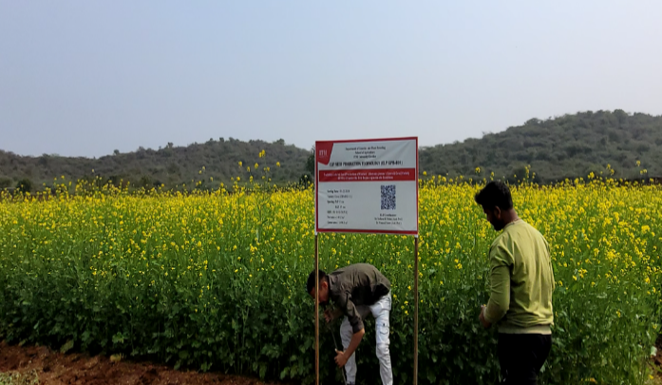Mustard Crop (Seed Production) field overview at flowering Stage

PHOTOGRAPHS OF ELP EXPO 4.0

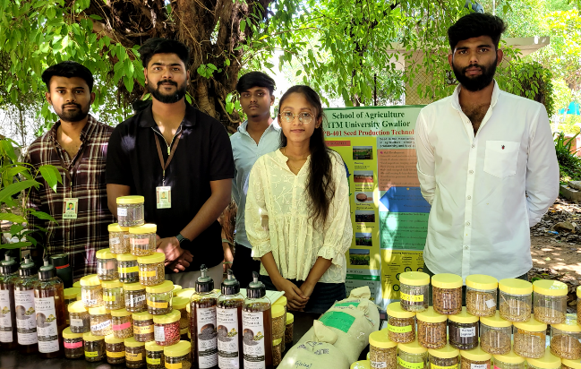Product demonstration at ELP Expo-4.O | 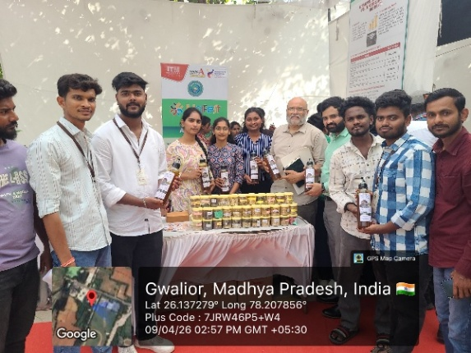Product demonstration at Unifest Festival
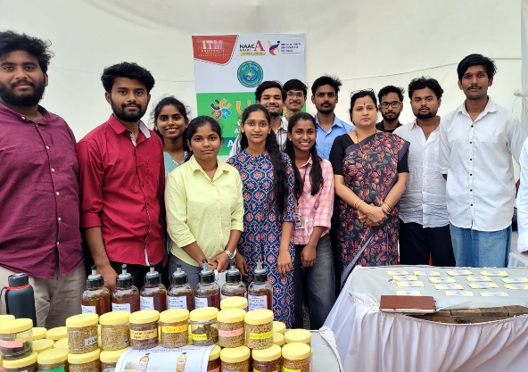Product demonstration at Unifest Festival | 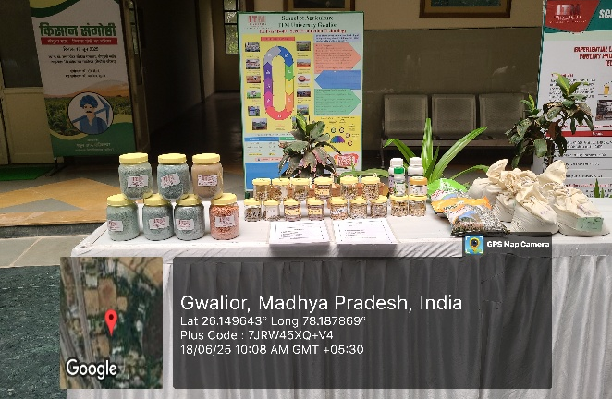ELP Expo during Kishan Gosthi-2025
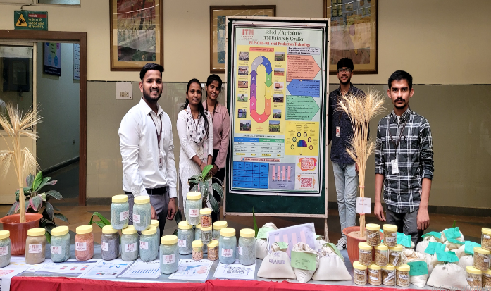Product demonstration at ELP Expo-3.O | 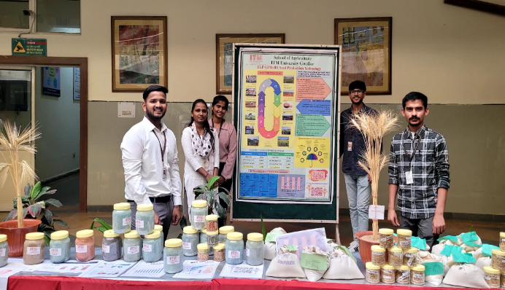Product demonstration at ELP Expo-3.O

7. LIST OF STUDENTS PARTICIPATED

S. No. | Name of Student | Enrollment No. | Programme
1 | Anad Swaroop Bhadoriya | BAGN1AG21183 | B. Sc. (Hons.) Agriculture
2 | Annapureddy Pradeepkumar Reddy | BAGN1AG22015 | B. Sc. (Hons.) Agriculture
3 | Allika Rakesh | BAGN1AG22016 | B. Sc. (Hons.) Agriculture
4 | Pothuganti Dharani | BAGN1AG22043 | B. Sc. (Hons.) Agriculture
5 | Mallam Bhargav | BAGN1AG22048 | B. Sc. (Hons.) Agriculture
6 | Durvesula Lakshmi Sai Kiran | BAGN1AG22053 | B. Sc. (Hons.) Agriculture
7 | Subhangi Vats | BAGN1AG22065 | B. Sc. (Hons.) Agriculture
8 | Chinthakindi Sai Preetham Goud | BAGN1AG22074 | B. Sc. (Hons.) Agriculture
9 | Nali Veera Gopi Krishna | BAGN1AG22110 | B. Sc. (Hons.) Agriculture
10 | Maripally Navya | BAGN1AG22111 | B. Sc. (Hons.) Agriculture
11 | Akhil Kumar S | BAGN1AG22141 | B. Sc. (Hons.) Agriculture
12 | Chilamakuri Jishnu Priya | BAGN1AG22142 | B. Sc. (Hons.) Agriculture
13 | Sadhana Kaur | BAGN1AG22250 | B. Sc. (Hons.) Agriculture
14 | Chatla Snigdha | BAG1NAG22316 | B. Sc. (Hons.) Agriculture
15 | Sreemanthula Sanjay Raj | BAG1NAG22317 | B. Sc. (Hons.) Agriculture
16 | Kathi Bharath Simha | BAG1NAG22318 | B. Sc. (Hons.) Agriculture
17 | Rathalavath Maha Durga Bai | BAG1NAG22324 | B. Sc. (Hons.) Agriculture
18 | Mudavath Gurukiran Naik | BAG1NAG22324 | B. Sc. (Hons.) Agriculture
19 | Meghraj Dhaneshwar | BAG1NAG22332 | B. Sc. (Hons.) Agriculture

8. CONCLUSION
The Experiential Learning Programme (ELP-GPB-401) successfully provided comprehensive exposure to students in seed production technology. Through systematic field activities, laboratory testing, and analytical learning, students developed strong technical and professional competencies.
The integration of practical training with scientific principles ensured holistic learning, preparing students for careers in seed technology, agribusiness, and research. The programme also highlighted the importance of quality seed production in achieving agricultural sustainability and productivity.

Floriculture and Landscaping
ELP-HORT-402

- To provide practical exposure in floriculture and landscaping practices
- To develop skills in nursery management and ornamental plant production
- To impart knowledge on landscape planning, design, and execution
- To enhance entrepreneurial skills and self-employment opportunities
- To familiarize students with marketing and business aspects of floriculture
- To promote teamwork, problem-solving ability, and decision-making skills

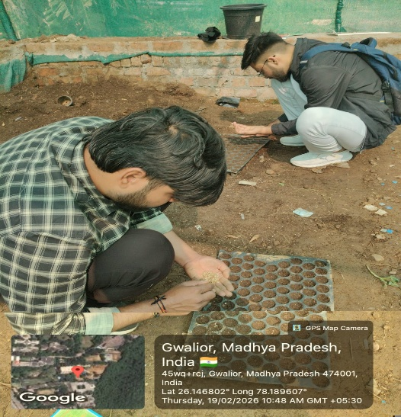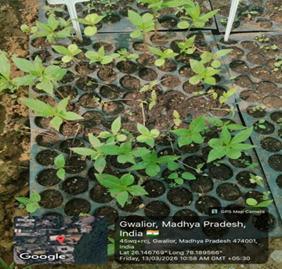

Plate 1: Seed Sowing in Pro-trays Plate 2: Seed Germination

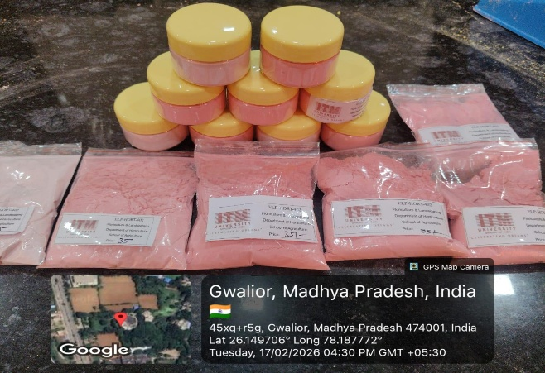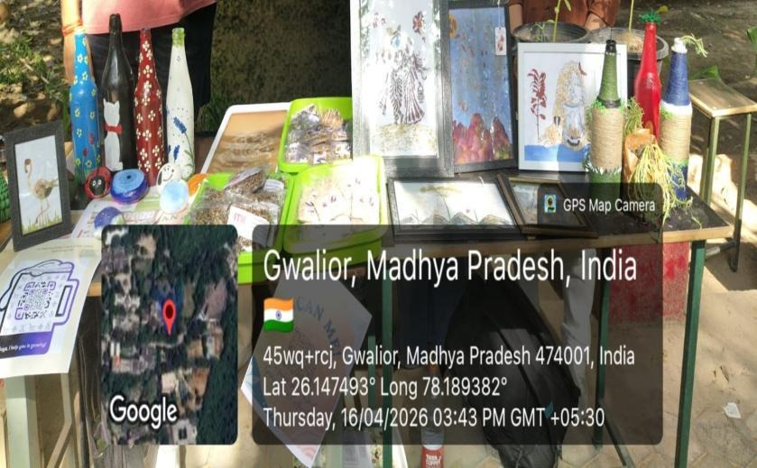
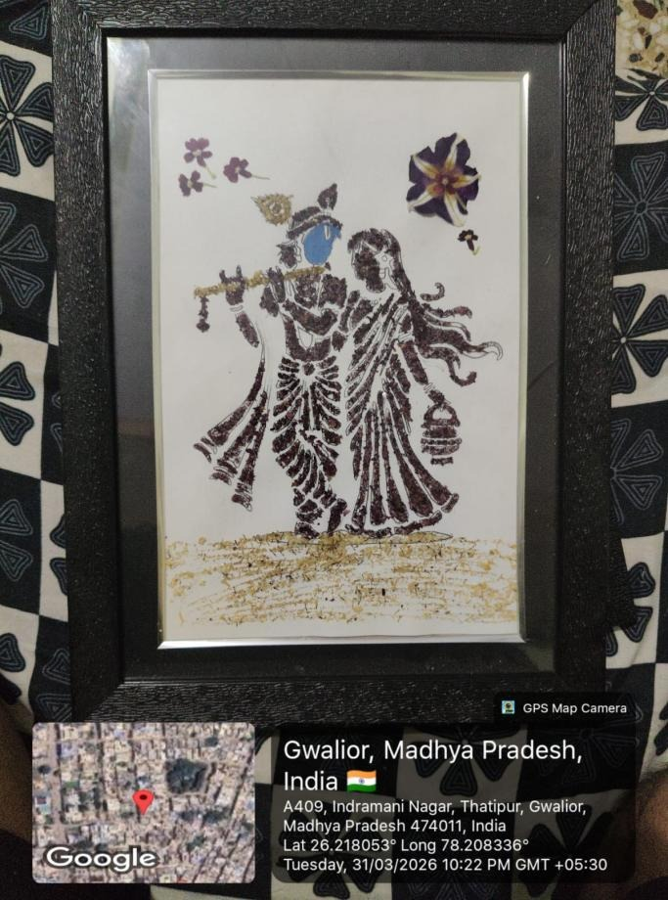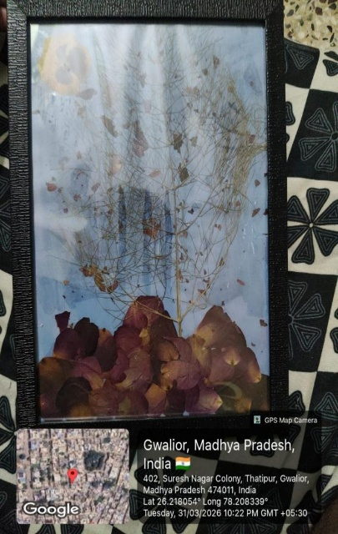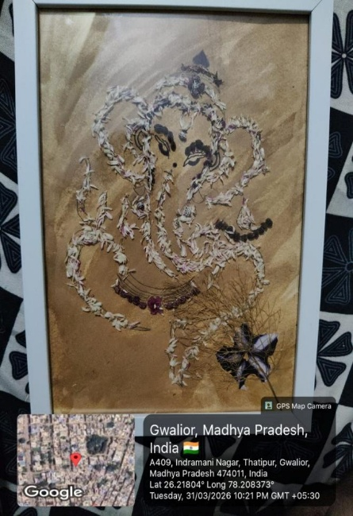

Figure2: Post Harvest and Value added Products

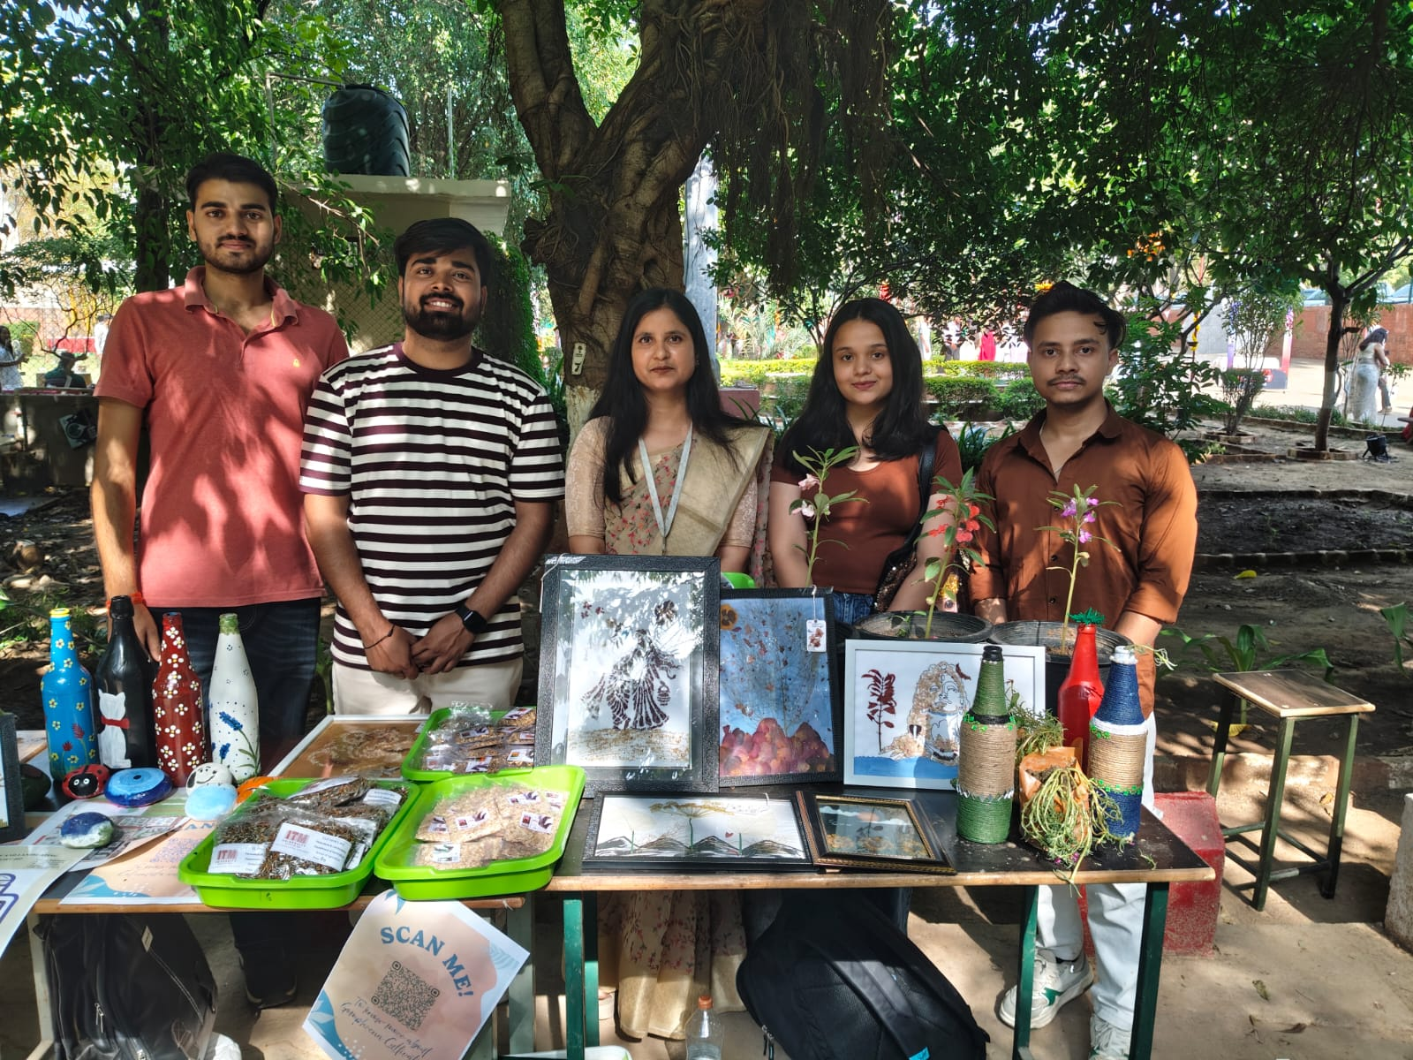
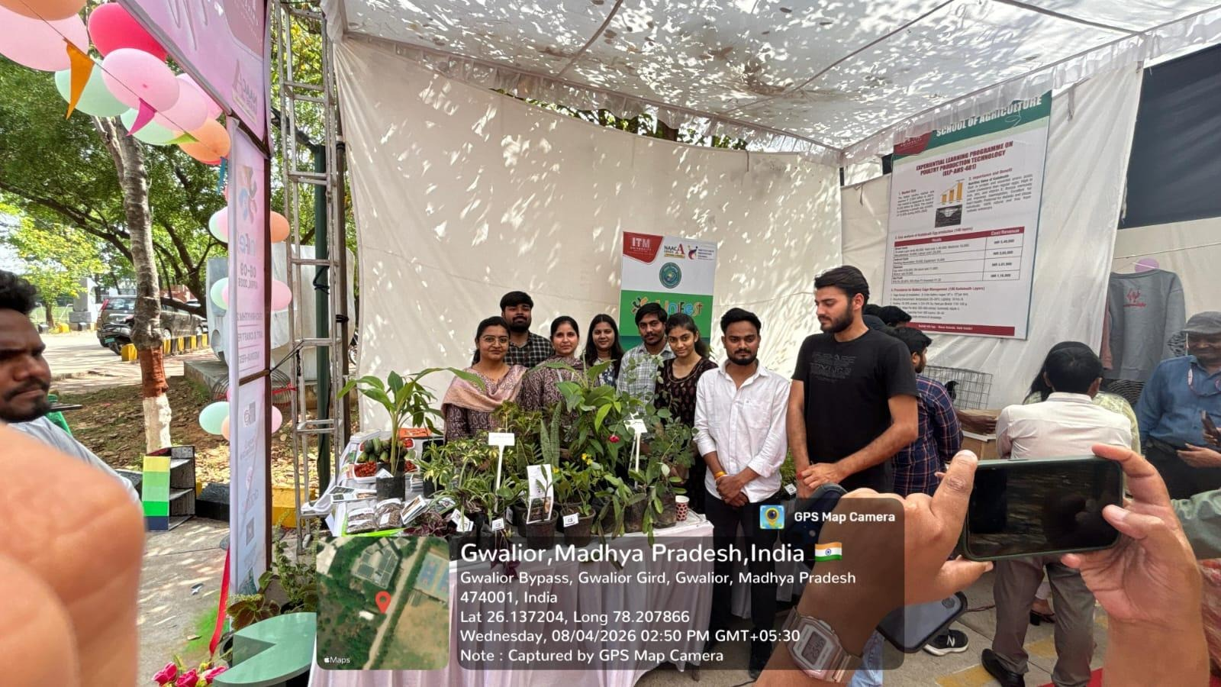
Figure3: ELP EXPO 4.0 and AGRI-FEST

7. List of Students Participated
S. No. | Name of Student | Enrollment No. | Programme/Department
 | Vaishnavi Agrawal | Bahn1ag22001 | B.Sc. (Hon.) Horticulture
 | Nikhil Sharma | Bahn1ag22008 | B.Sc. (Hon.) Horticulture
 | Abhimanyu Kumar | BAGN1AG22159 | B.Sc. (Hon.) Agriculture
 | Ritik Sharma | Bahn1ag22003 | B.Sc. (Hon.) Horticulture
 | Kedar Singh Rawat | BAHN1AG22005 | B.Sc. (Hon.) Horticulture
 | Abhishek Singh | BAHN1AG22013 | B.Sc. (Hon.) Horticulture
 | Thati .Usha Pravalika | Bag1nag22299 | B.Sc. (Hon.) Agriculture
 | Kuldeep Singh Dhakar | Bahn1ag22002 | B.Sc. (Hon.) Horticulture
 | Kunal dhakar | Bagn1ag22092 | B.Sc. (Hon.) Agriculture
 | Khushi Nayak | Bagn1ag22021 | B.Sc. (Hon.) Agriculture
 | Abhishek Singh | Bagn1ag22225 | B.Sc. (Hon.) Agriculture
 | Khushi Singh | Bagn1ag22248 | B.Sc. (Hon.) Agriculture

Commercial Nursery Establishment and Mass Multiplication of Horticultural Crops
ELP-HORT-404

- To impart knowledge on the planning and layout of commercial nurseries.
- To develop skills in preparation and management of different growing media.
- To understand the role of plant growth regulators in propagation and nursery development.
- To train participants in nursery raising techniques for various horticultural crops.
- To provide practical exposure to vegetative propagation methods such as cutting, layering, stooling, budding, and grafting.
- To enhance understanding of mass multiplication techniques.
- To introduce marketing strategies for nursery plants and seedlings.
- To create awareness about entrepreneurial opportunities in nursery management.
- To provide field exposure through surveys and visits to commercial nurseries and tissue culture laboratories.
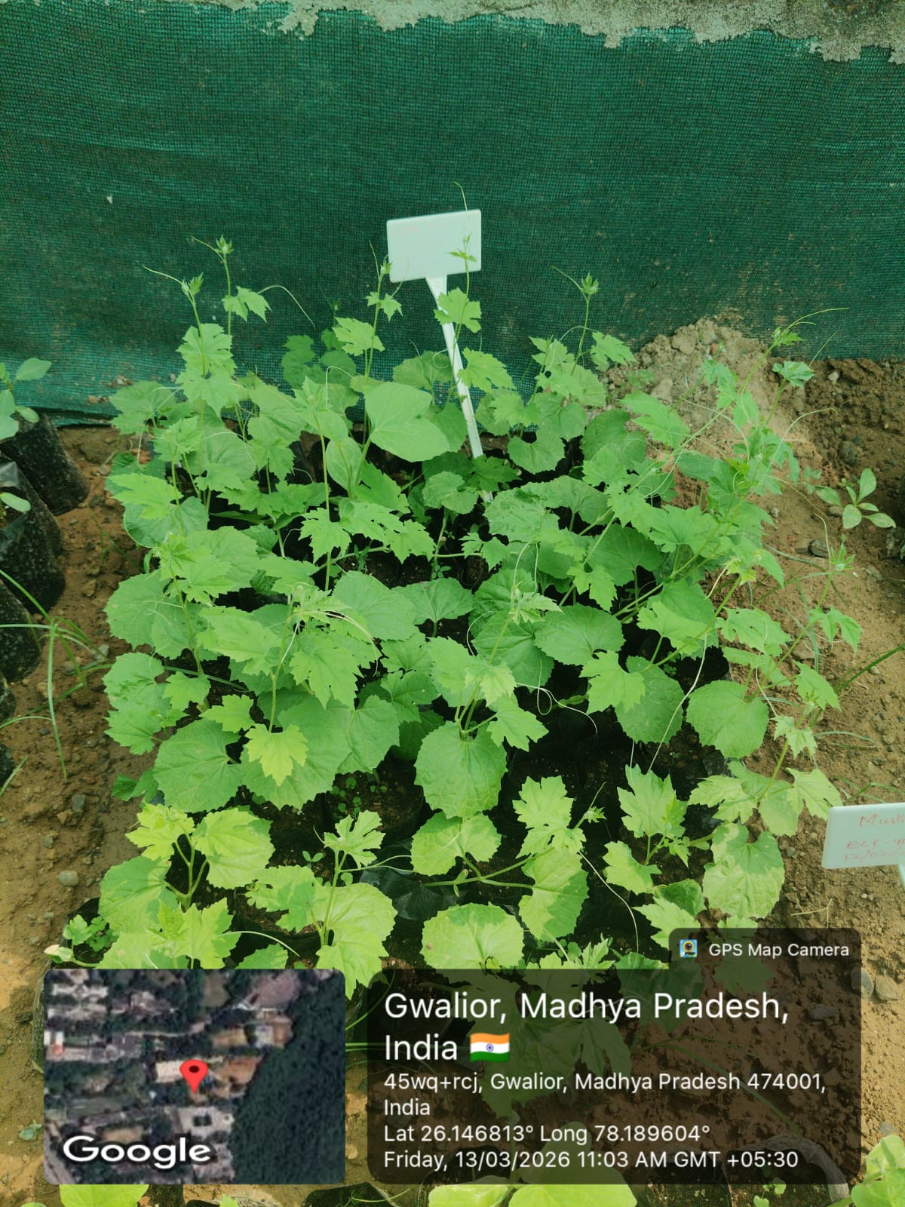
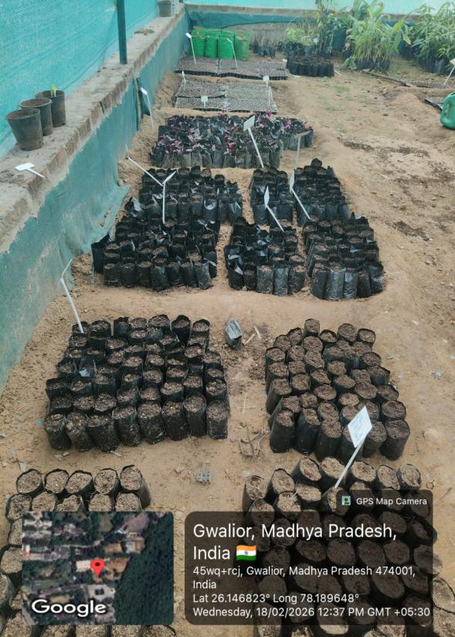
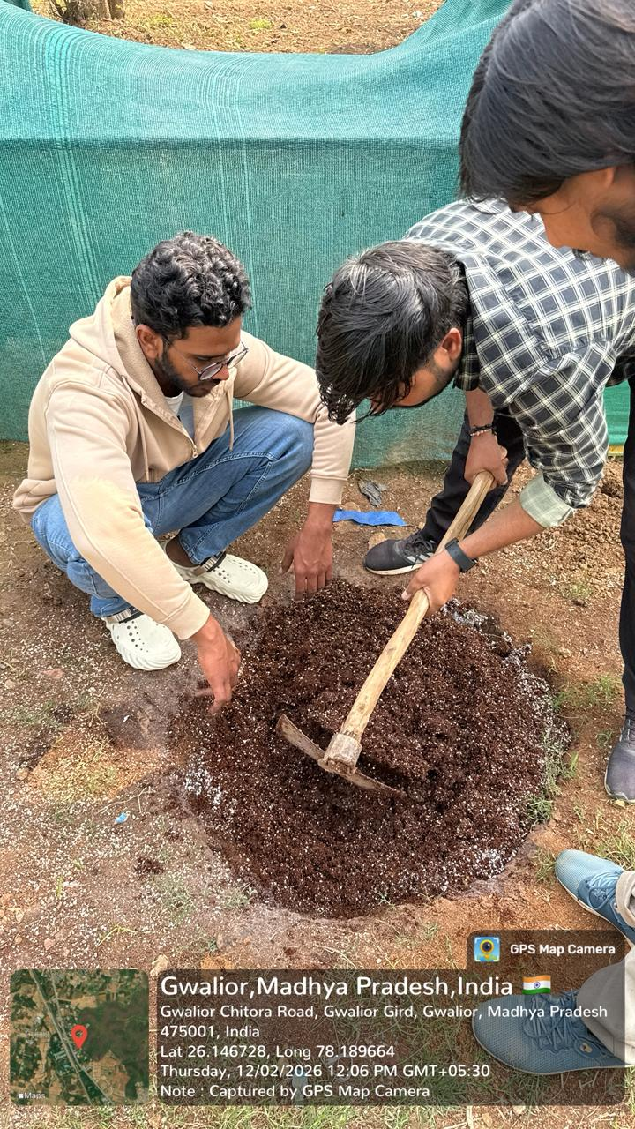
Best Photographs of Activities
Media Preparation Polybag Nursery Setup Seedlings ready for sale

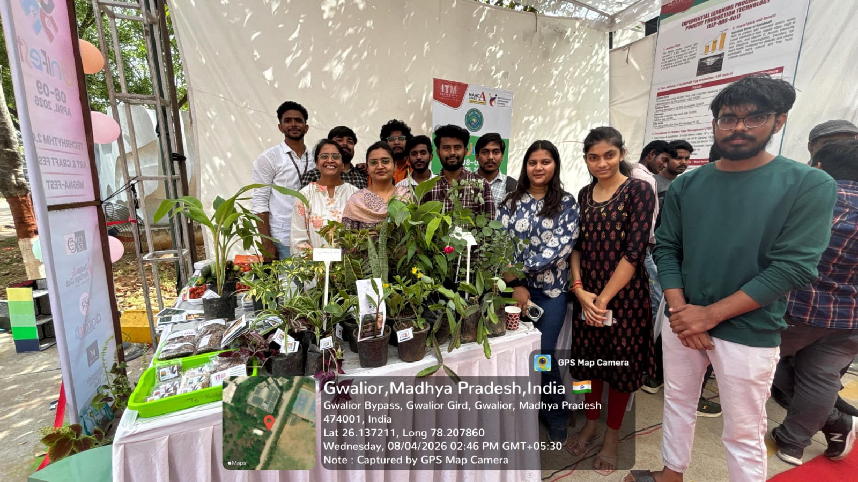
Photographs of Unifest- Agrifest
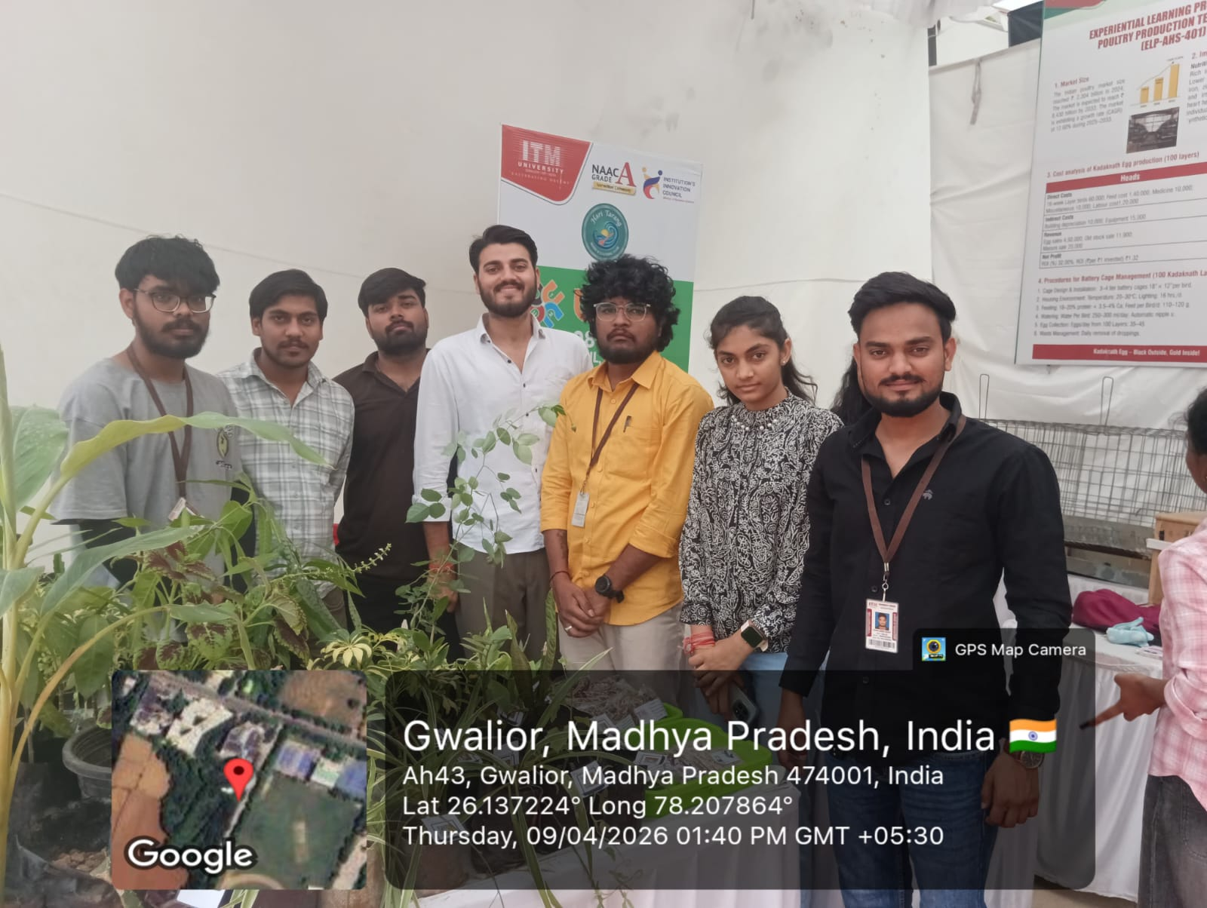

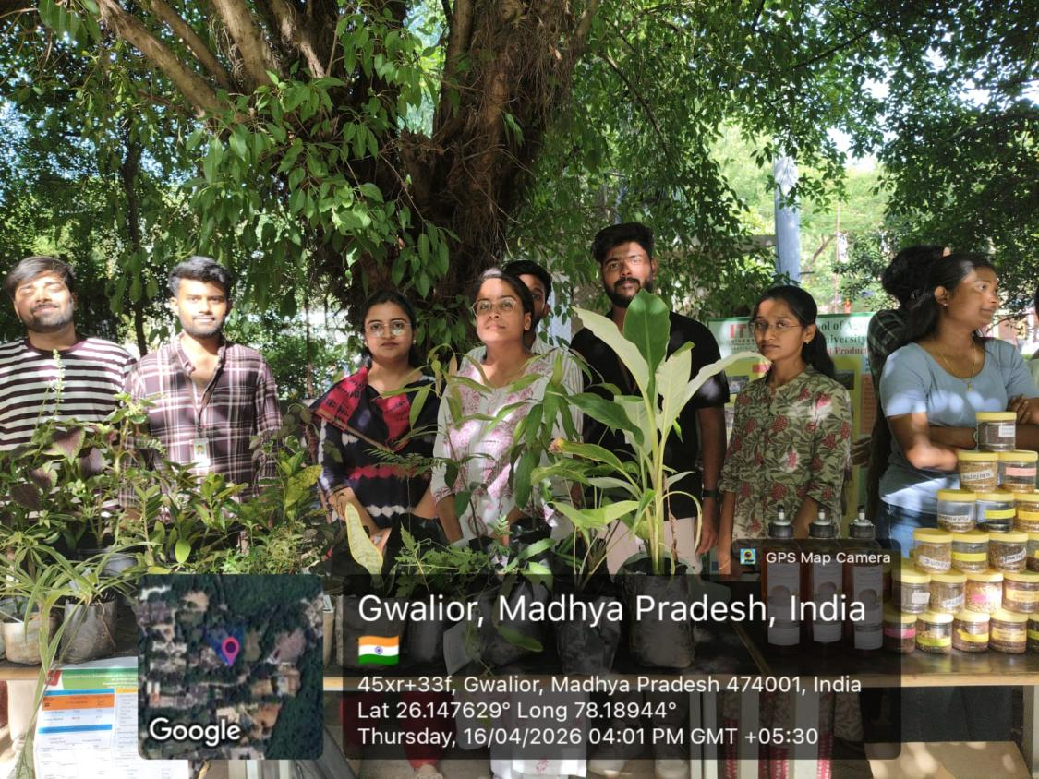
Photographs of ELP Expo 4.0
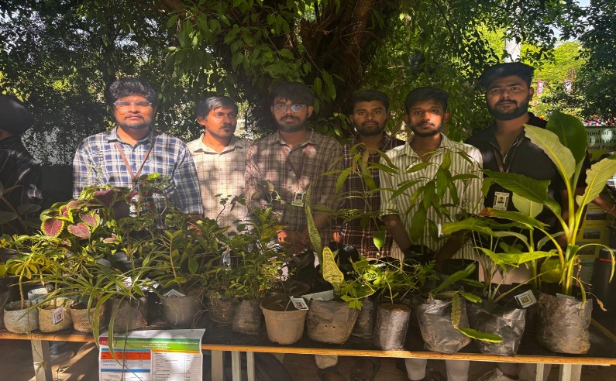

List of Students Participated
S. No. | Name of Student | Enrollment No. | Programme/Department
 | YASHEEN SHAIK | BAGN1AG22039 | B.Sc. (Hon.) Agriculture
 | AKHIL KUMAR S | BAGN1AG22141 | B.Sc. (Hon.) Agriculture
 | ABHISHEK SINGH | BAGN1AG22225 | B.Sc. (Hon.) Agriculture
 | MARIPALLY NAVYA | BAGN1AG22111 | B.Sc. (Hon.) Agriculture
 | SNEHA TOMAR | BAGN1AG22005 | B.Sc. (Hon.) Agriculture
 | BAKKI MANISH | BAHN1AG22020 | B.Sc. (Hon.) Horticulture
 | EDURURI JAGAN MOHAN REDDY | BAHN1AG22018 | B.Sc. (Hon.) Horticulture
 | ABHISHEK SINGH | BAHN1AG22013 | B.Sc. (Hon.) Horticulture
 | VAISHNAVI AGRAWAL | BAHN1AG22001 | B.Sc. (Hon.) Horticulture
 | KULDEEP SINGH DHAKAR | BAHN1AG22002 | B.Sc. (Hon.) Horticulture

Protected Cultivation of High Value Horticulture Crops
ELP-HORT-405
- To understand protected structure establishment and management.
- To develop skills in media, soil treatment, and bed preparation.
- To learn cultivation and intercultural practices of high-value crops.
- To understand innovative vegetable production methods.
- To develop economic analysis skills in horticulture.

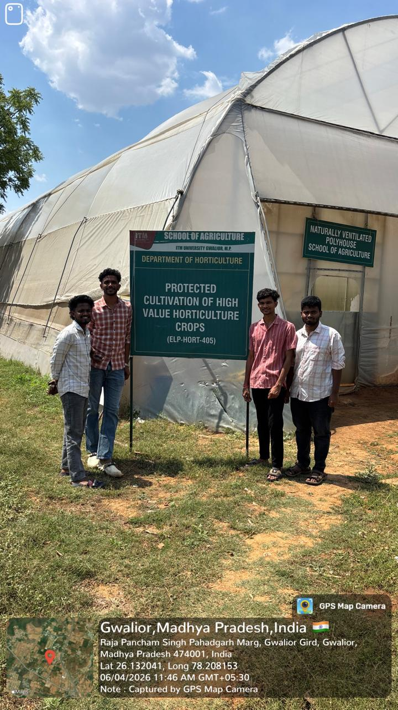
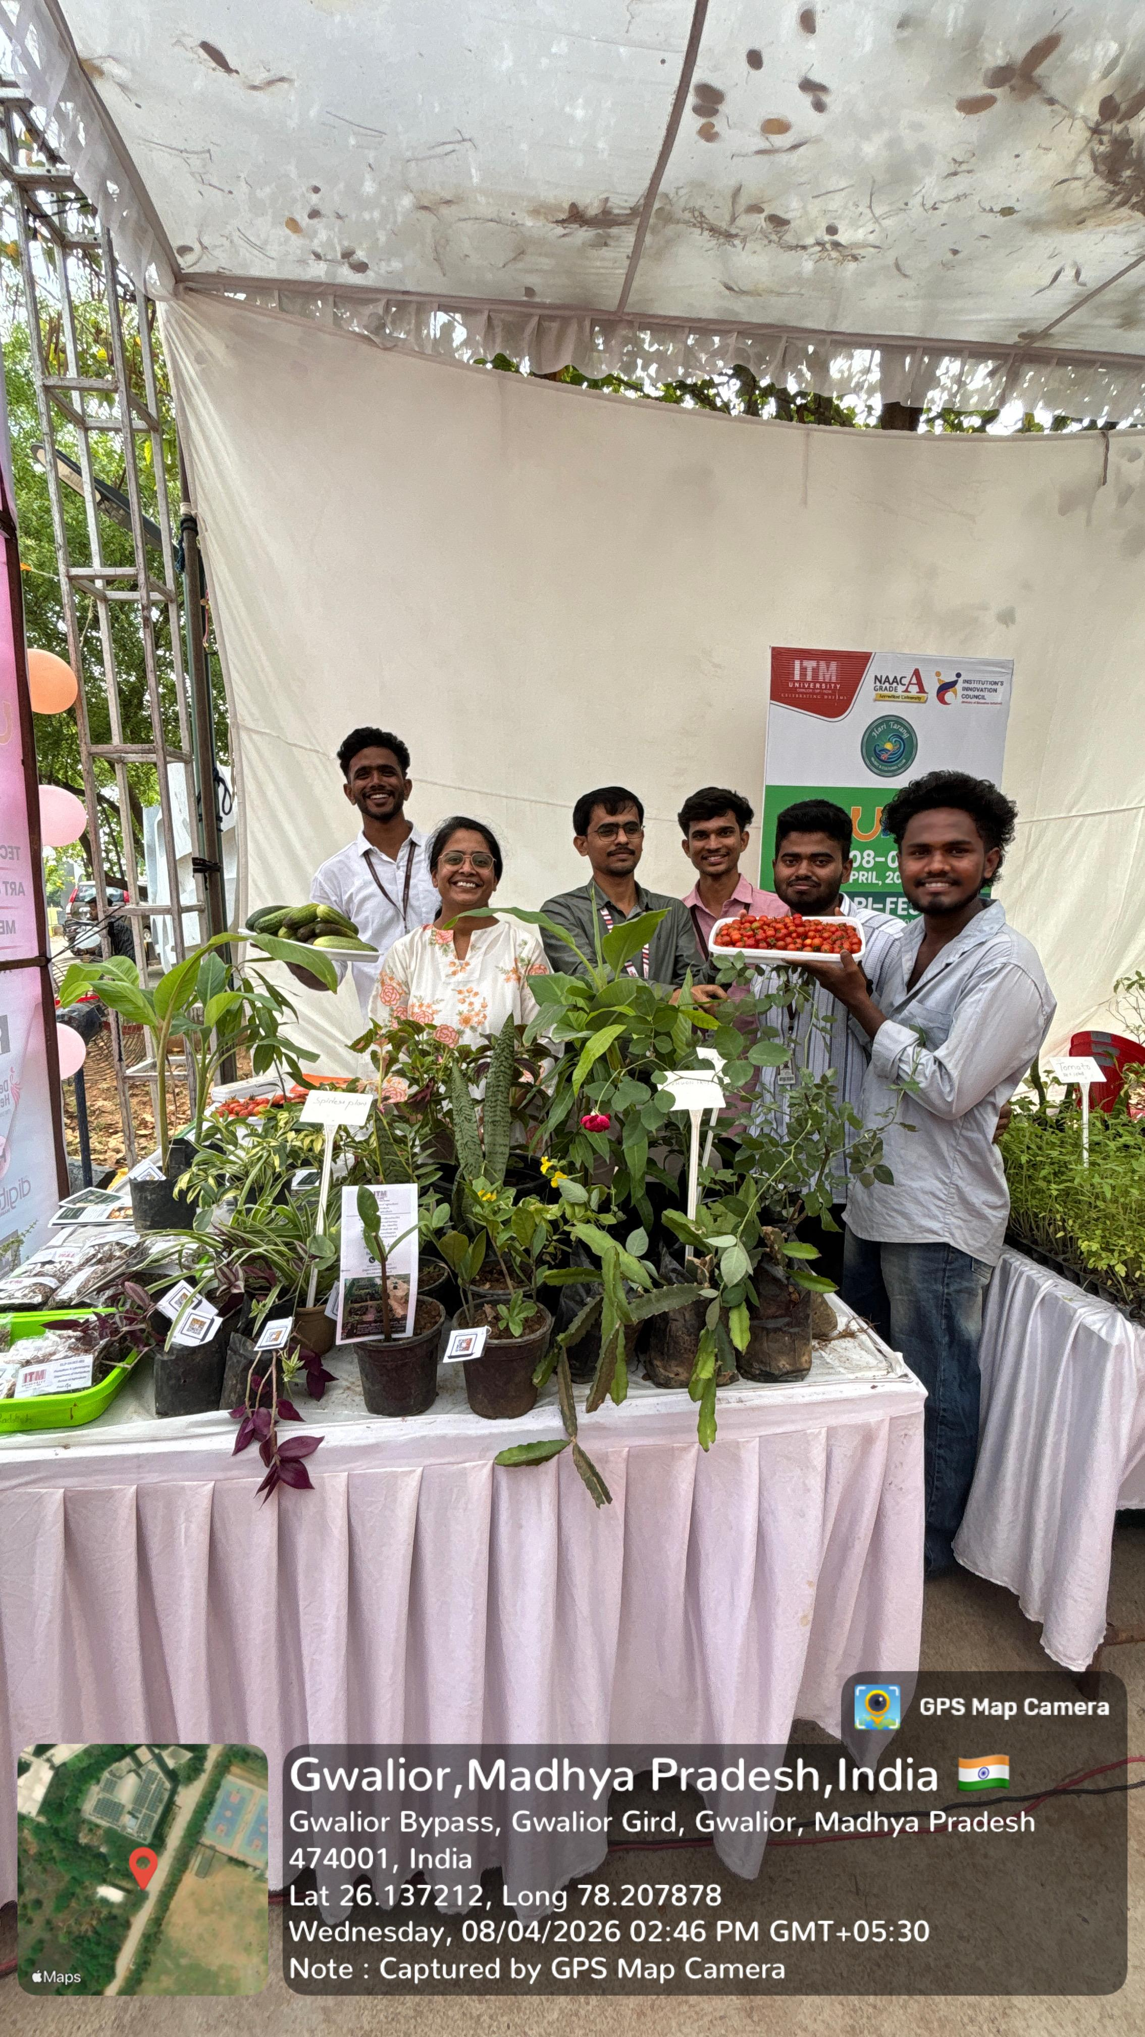
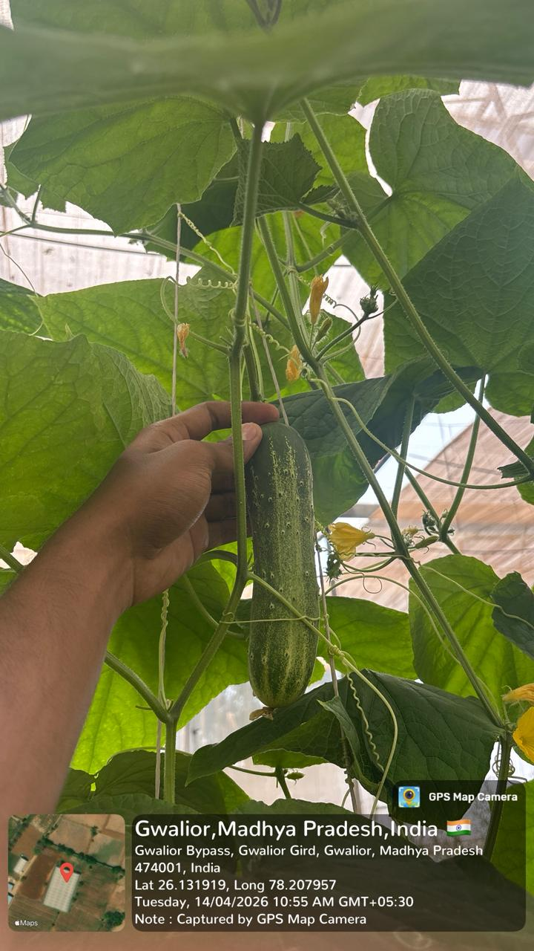 | 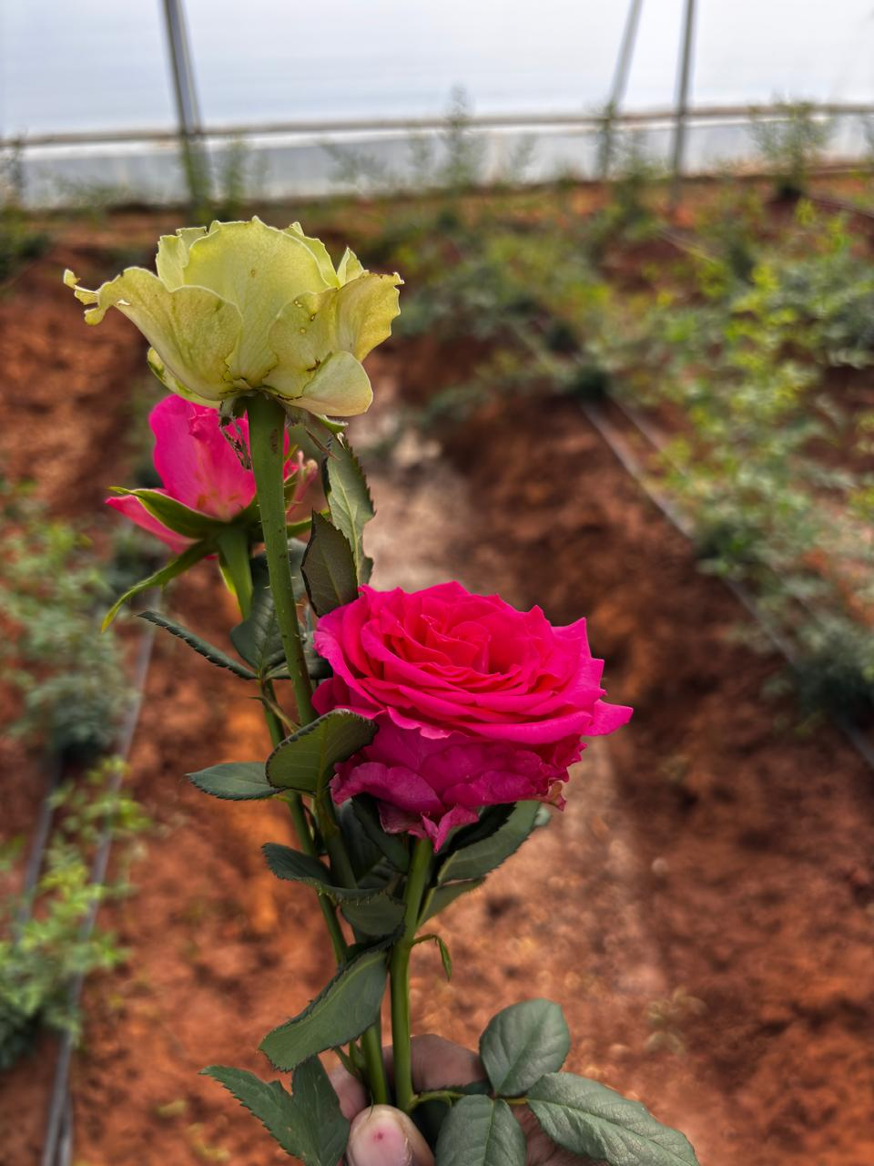
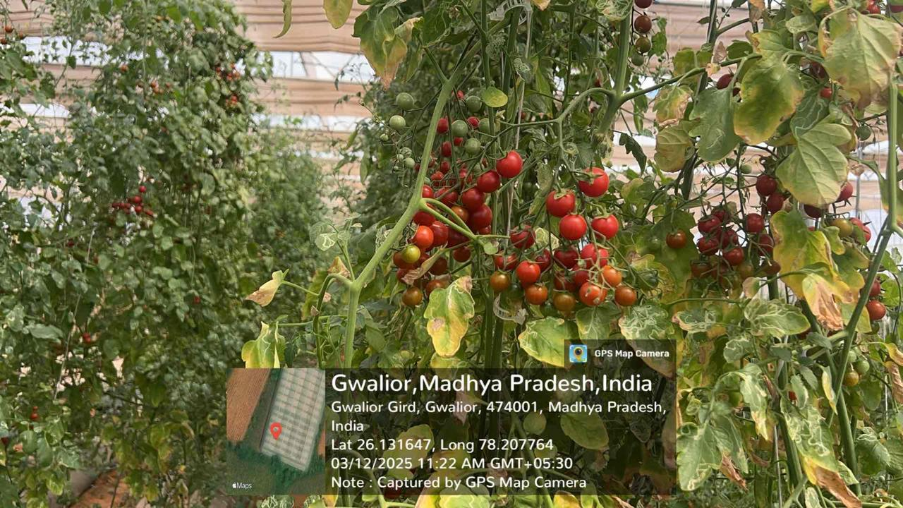
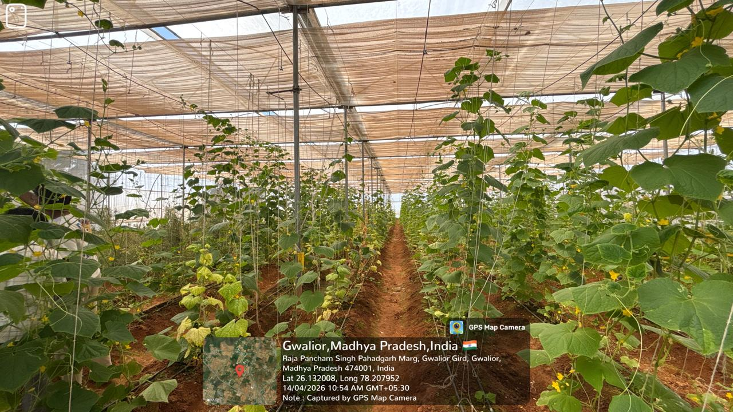

List of Students Participated
S. No. | Name of Student | Enrollment No. | Programme/Department
 | DURVESULA LAKSHMI SAI KIRAN | BAGN1AG22053 | B.Sc. (Hon.) Agriculture
 | YASHEEN SHAIK | BAGN1AG22039 | B.Sc. (Hon.) Agriculture
 | GANGA SAGAR | BAGN1AG22182 | B.Sc. (Hon.) Agriculture
 | ANNAPUREDDY PRADEEP KUMAR REDDY | BAGN1AG22015 | B.Sc. (Hon.) Agriculture

Organic Production Technology
ELP-AGRON-402

- To provide students with hands-on training in organic farming practices, thereby enhancing their practical knowledge and field-level skills.
- To enable students to understand the fundamental principles of organic agriculture, including crop rotation, mixed cropping, soil health management, and maintenance of ecological balance.
- To plan, manage, and operate organic farming unit as a business enterprise, including aspects of cost estimation and profit analysis of the different crops.
- To familiarize students with organic certification procedures and standards under schemes such as the National Programme for Organic Production (NPOP).
- To enhance the decision-making capacity of students by exposing them to real-time situations in crop production, pest and disease management, and efficient resource utilization.
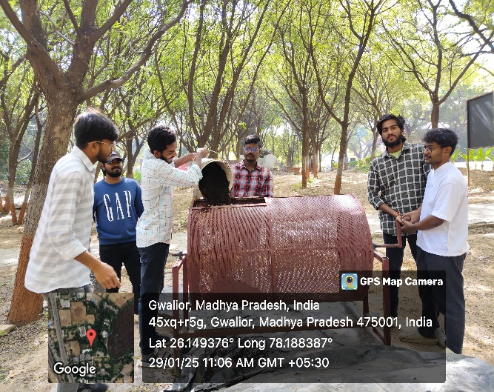 | 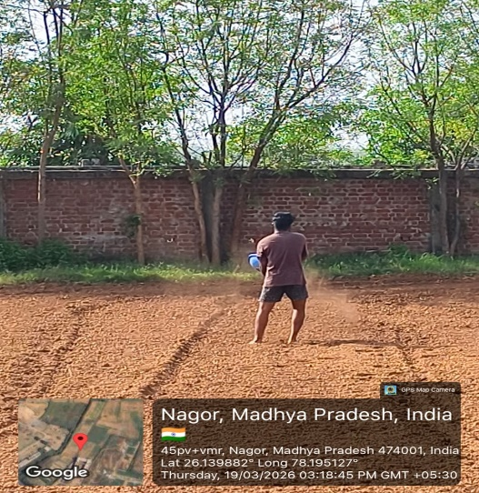
Plate: 1 Preparation and application of vermicompost

Plate: 2 General view of the field
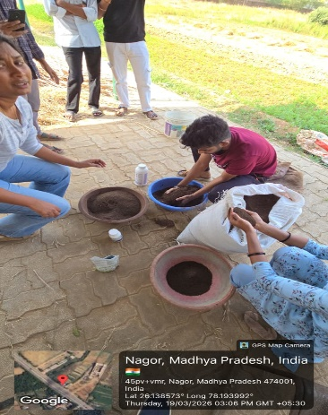 | 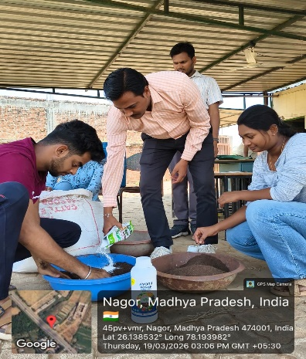 | 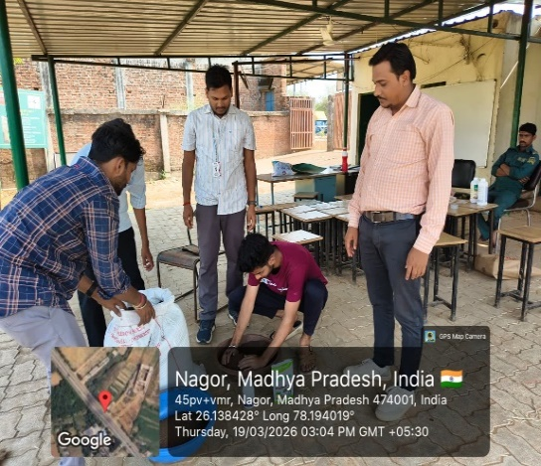
Plate: 3 Seed treatment with different biofertilizers
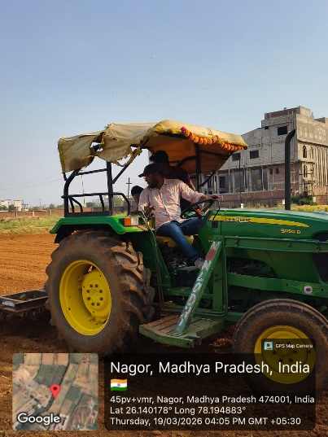 | 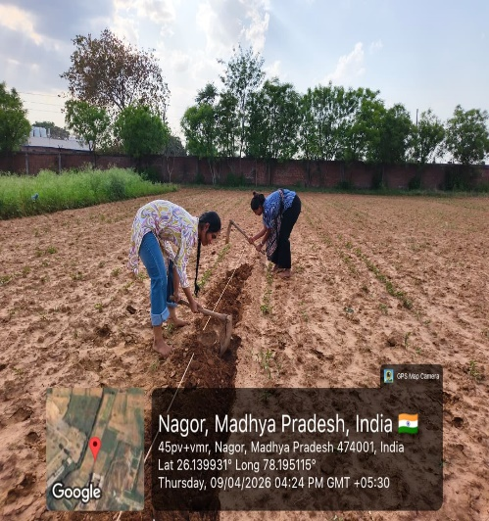 | 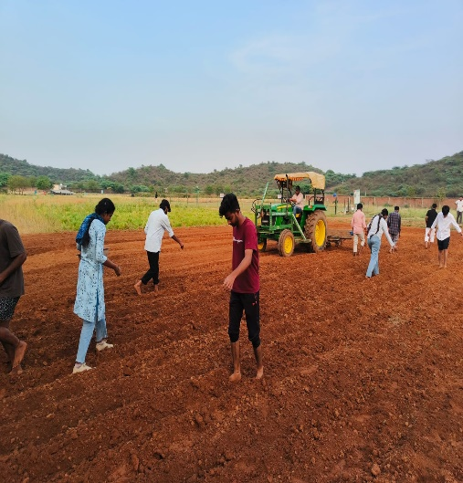
Plate: 4 Field Preparation and Sowing
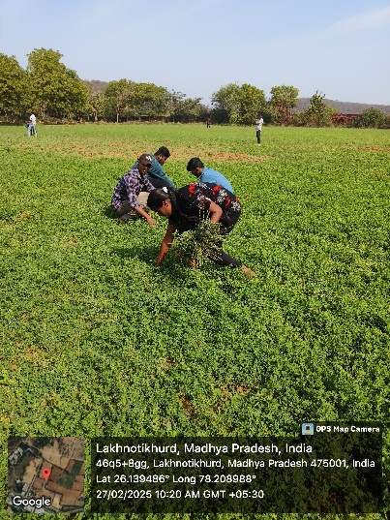 | 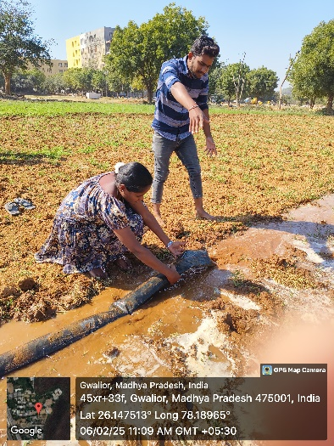 | 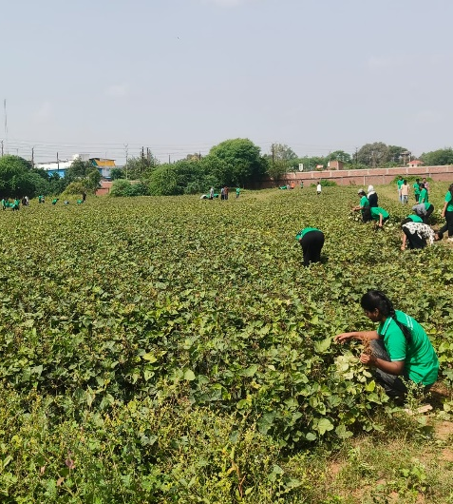
Plate: 5 Hand weeding, Irrigation and Harvesting

List of Students Participated
S. No. | Name of Student | Roll No. | Programme
 | G. Sharmila Naidu | BAGNAG 22098 | B.Sc. (Hons.) Agriculture
 | Ragini Sinha | BAGNAG 22114 | B.Sc. (Hons.) Agriculture
 | C. H. Snigdha | BAGNAG 22316 | B.Sc. (Hons.) Agriculture
 | S. Sanjay Ray | BAGNAG 22317 | B.Sc. (Hons.) Agriculture
 | M. Kiran Nayak | BAGNAG 22325 | B.Sc. (Hons.) Agriculture
 | R. Maha Durga | BAGNAG 22324 | B.Sc. (Hons.) Agriculture

Commercial Horticulture (Vegetable and Spice Crop Production)
(ELP-HORT-401)
- Promote scientific cultivation of vegetables and spices.
- Enhance yield and profitability.
- Develop agri-entrepreneurship skills.
- Improve post-harvest handling and marketing

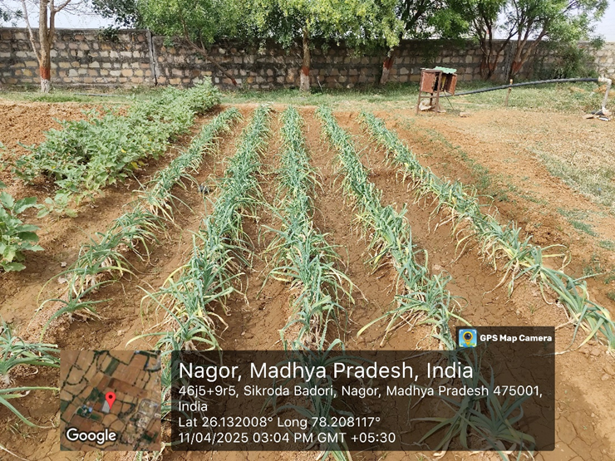
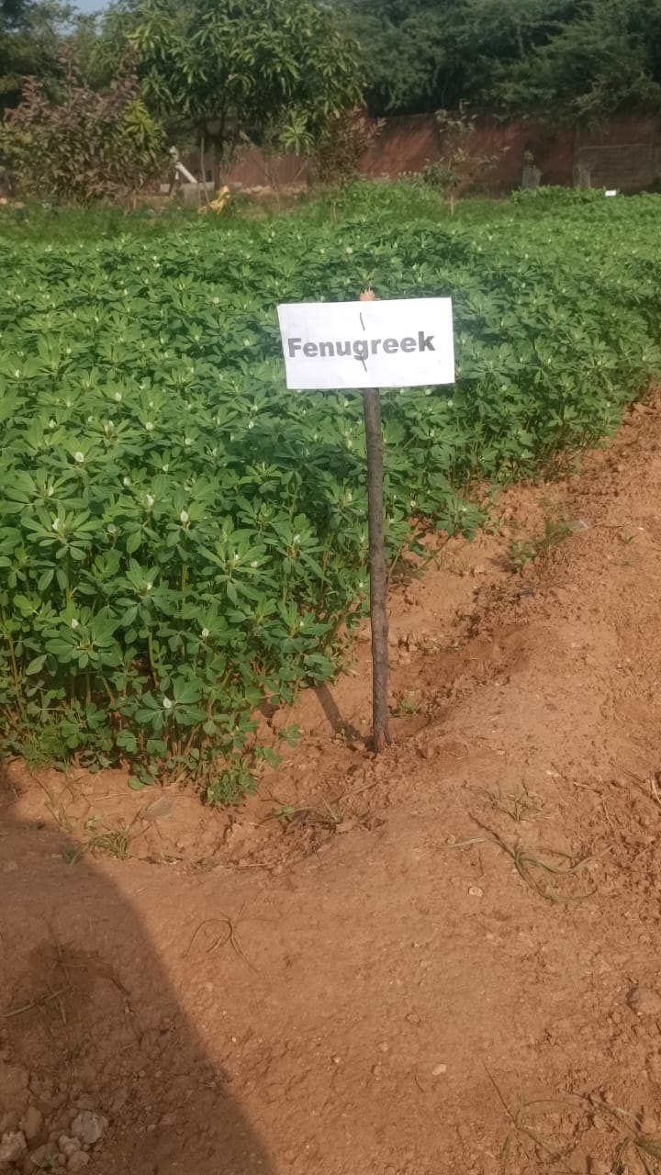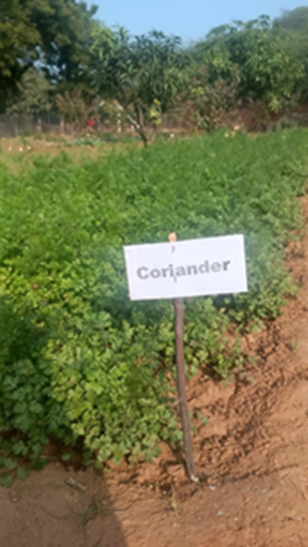

Processing of Fruits and Vegetables for Value Addition
(ELP-HORT-403)

- To develop hands-on skills in fruit and vegetable processing.
- To teach techniques for making marketable processed products.
- To encourage students to start their own food ventures.
- To minimize post-harvest waste through preservation.
- To support income and job creation in rural areas.

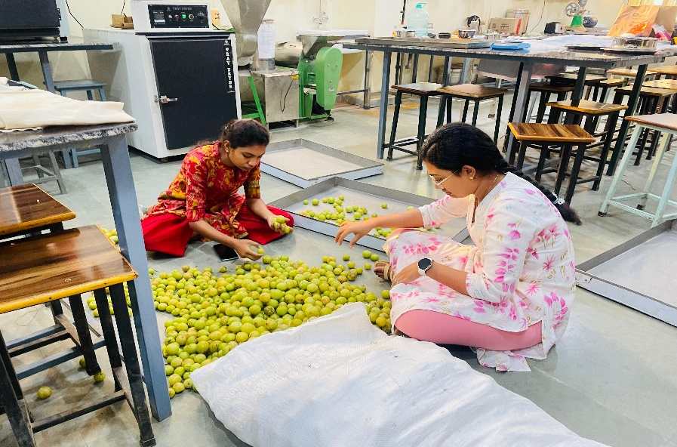
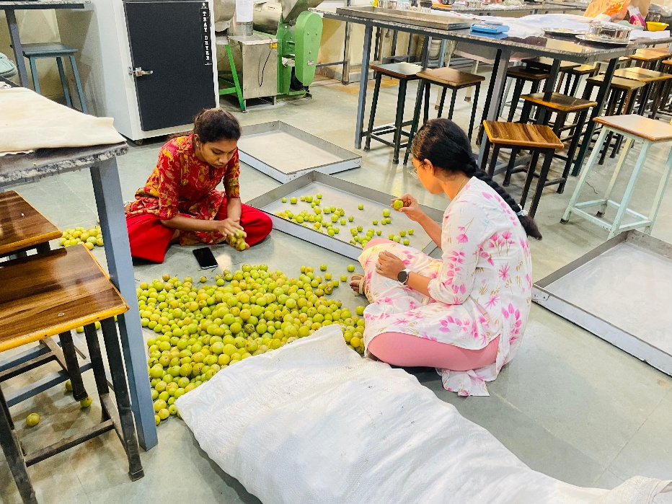
Processing of Aonla for powder formulation
Sorting of Aonla

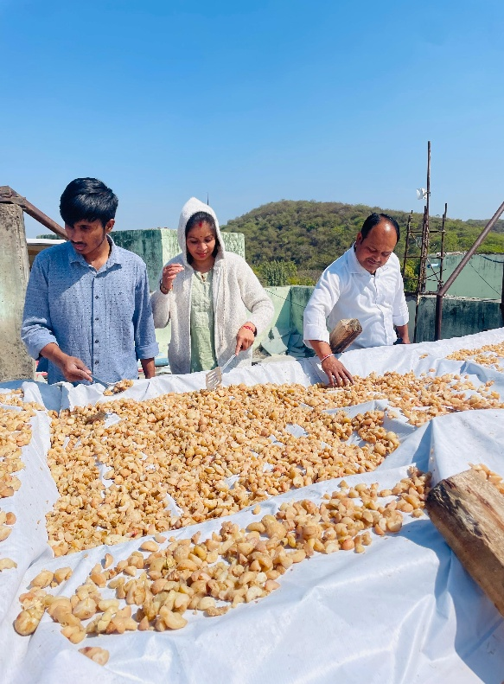
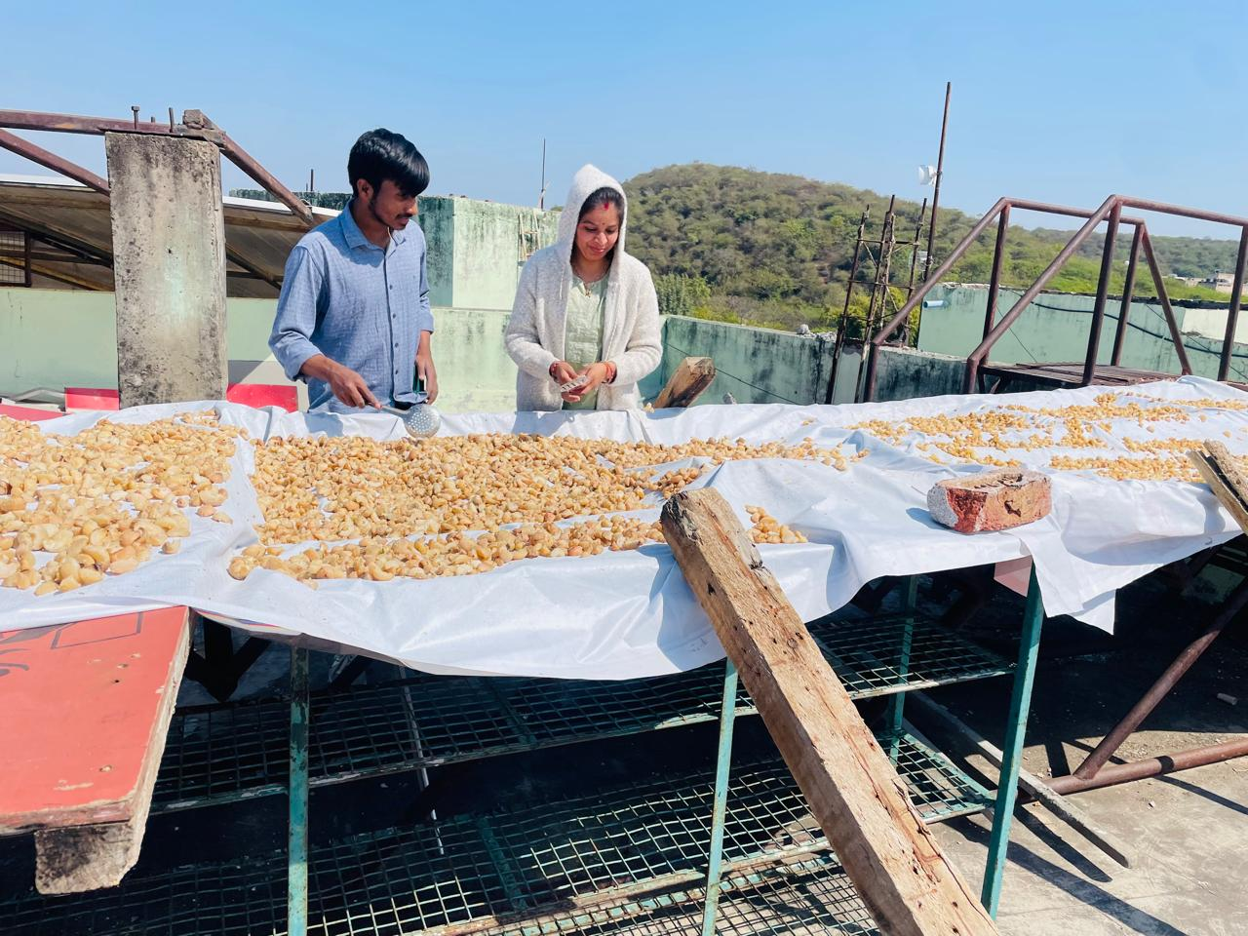
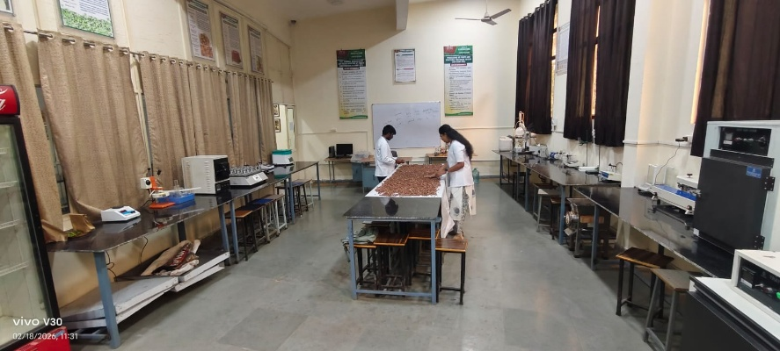
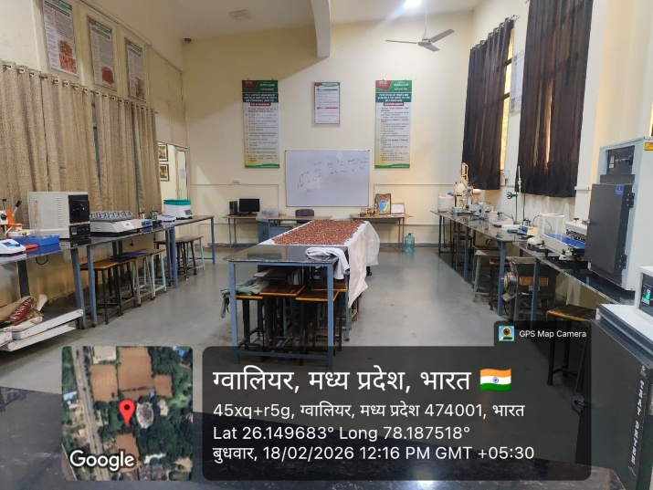
Sun drying of Aonla

List of Students Participated
S. No. | Name of Student | Roll No. | Programme
 | THATI USHA PRAVALIKA | BAG1NAG22299 | B.Sc. (Hons.) Agriculture
 | SHAIK MOHAMMED MUSTAQEEM | BAGN1AG22196 | B.Sc. (Hons.) Agriculture
 | VUDDANTI SRAVANI | BAGN1AG22207 | B.Sc. (Hons.) Agriculture
 | GUNA YASWANT | BAGN1AG22081 | B.Sc. (Hons.) Agriculture

Commercial Agriculture (Poultry Production Technology)
ELP-AHS-411

- To develop skills in poultry breeding, feeding, and housing.
- To gain knowledge of hatchery, nutrition, and health care.
- To learn waste management and biosecurity practices.
- To build poultry entrepreneurship skills.
- To understand marketing, economics, and food security role.

Photographs of Activities
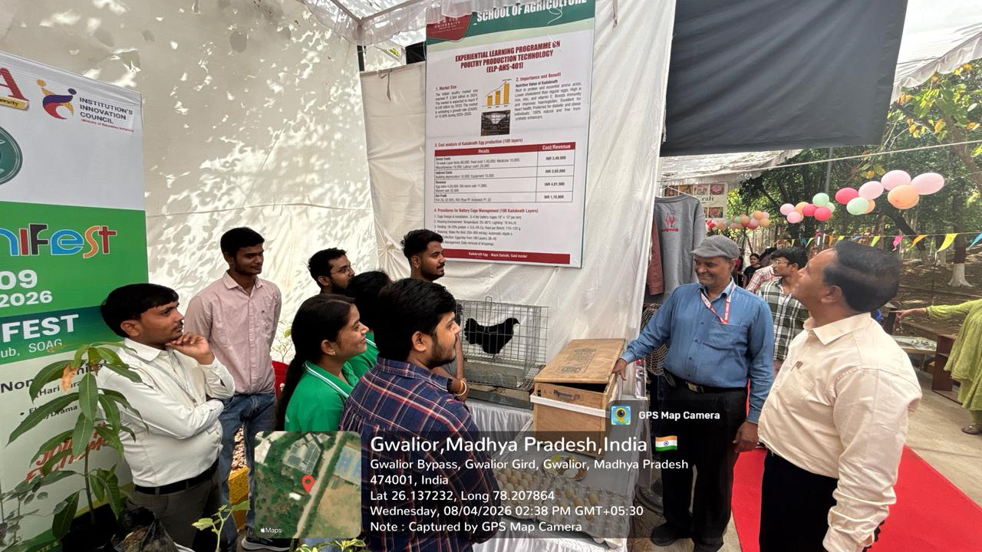

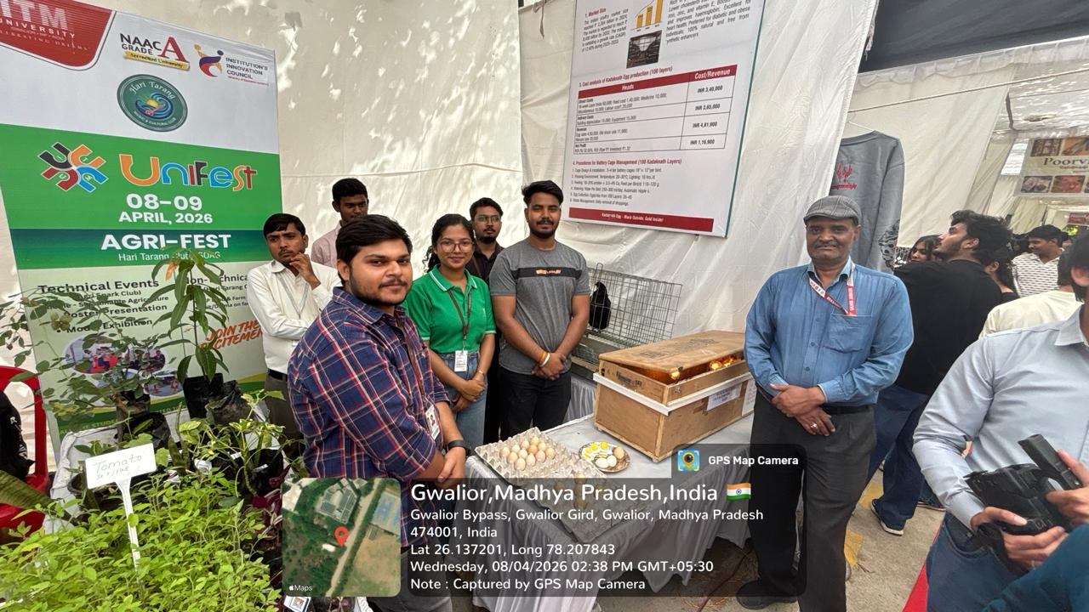

Students involved in the activities
Photographs of ELP Expo 4.0
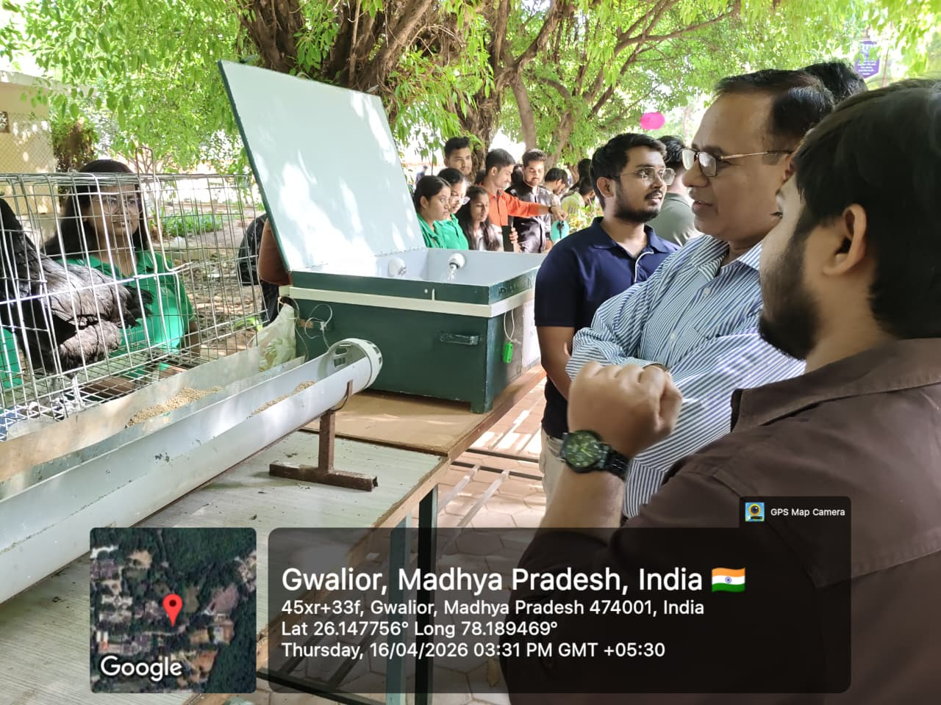

Explaining guests about Kadaknath breed
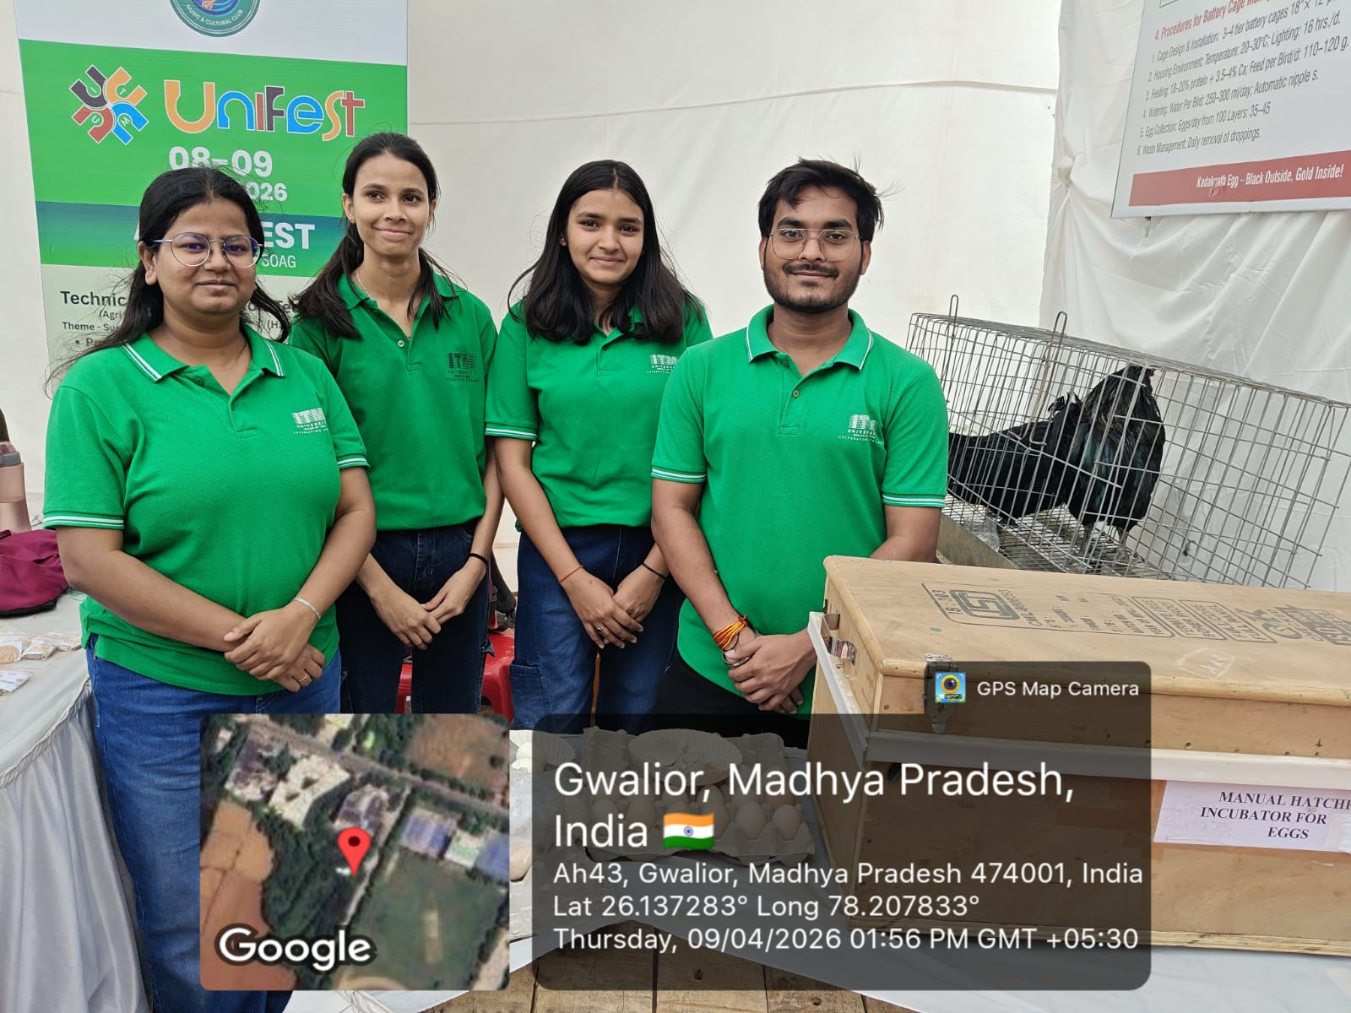

Students involved in the activity

List of Students Participated
S. No. | Name of Student | Enrollment No. | Programme
1 | Manvendra Upadhyay | BAGN1AG22002 | B.Sc. (Hons.) Agriculture
2 | Animeha Parmar | BAGN1AG22006 | B.Sc. (Hons.) Agriculture
3 | Kashish Tripathi | BAGN1AG22007 | B.Sc. (Hons.) Agriculture
4 | Shreya | BAGN1AG22008 | B.Sc. (Hons.) Agriculture
5 | Ankit | BAGN1AG22013 | B.Sc. (Hons.) Agriculture
6 | Sourav Rajput | BAGN1AG22014 | B.Sc. (Hons.) Agriculture
7 | Tanishq Raj Singh | BAGN1AG22028 | B.Sc. (Hons.) Agriculture
8 | Rimjhim Bharti | BAGN1AG22030 | B.Sc. (Hons.) Agriculture
9 | Udit Rajput | BAGN1AG22033 | B.Sc. (Hons.) Agriculture
10 | Anuroodh Shivhare | BAGN1AG22036 | B.Sc. (Hons.) Agriculture
11 | Saurabh Kumar | BAGN1AG22050 | B.Sc. (Hons.) Agriculture
12 | Anushmita Shrivastav | BAGN1AG22054 | B.Sc. (Hons.) Agriculture
13 | Jay Kumar | BAGN1AG22055 | B.Sc. (Hons.) Agriculture
14 | Shiva Yadav | BAGN1AG22056 | B.Sc. (Hons.) Agriculture
15 | Khushi Sahu | BAGN1AG22057 | B.Sc. (Hons.) Agriculture
16 | Nishith Sharma | BAGN1AG22061 | B.Sc. (Hons.) Agriculture
17 | Aakarsh Samuel | BAGN1AG22069 | B.Sc. (Hons.) Agriculture
18 | Khushi Bhadoriya | BAGN1AG22075 | B.Sc. (Hons.) Agriculture
19 | Kalpana | BAGN1AG22078 | B.Sc. (Hons.) Agriculture
20 | Subhanshu Kumar Choubey | BAGN1AG22082 | B.Sc. (Hons.) Agriculture
21 | Himadri Jain | BAGN1AG22089 | B.Sc. (Hons.) Agriculture
22 | Ujjwal Kumar Dubey | BAGN1AG22117 | B.Sc. (Hons.) Agriculture
23 | Rishabh Kushwah | BAGN1AG22120 | B.Sc. (Hons.) Agriculture
24 | Anuj Joshi | BAGN1AG22180 | B.Sc. (Hons.) Agriculture
25 | Pritthu Sharma | BAGN1AG22201 | B.Sc. (Hons.) Agriculture
26 | Prashant Agnihotri | BAGN1AG22204 | B.Sc. (Hons.) Agriculture
27 | Rudra Rajawat | BAGN1AG22221 | B.Sc. (Hons.) Agriculture
28 | Jaskeerat Singh | BAGN1AG22279 | B.Sc. (Hons.) Agriculture

